Final Year Design Project
Digital Housing Society

By

PROJECT ID: BSIT22-G23

Shawana Gohar | 076892
Memoona Akram | 076951
Sonia Saleem | 077008

Under the supervision of
Prof. Muhammad Asif

Bachelor of Science in Department of Computer Sciences & Information Technology (2022-2026)
GOVT. ISLAMIA GRADUATE COLLEGE, GUJRANWALA
Digital Housing Society

A project presented to
University of the Punjab, Lahore

In partial fulfilment
of the requirement for the degree of

Bachelor of Science in Department of Computer Sciences & Information Technology
(2022-2026)
By
Shawana Gohar | 076892
Memoona Akram | 076951
Sonia Saleem | 077008

GOVT. ISLAMIA GRADUATE COLLEGE, GUJRANWALA

DECLARATION
We hereby declare that this software, neither whole nor as a part, has been copied out from any source. It is further declared that we have developed this software and accompanied report entirely based on our personal efforts. If any part of this project is proved to be copied out from any source or found to be reproduction of some other, we will stand by the consequences. No portion of the work presented has been submitted of any application for any other degree or qualification of this or any other university or institute of learning.

Signature: -------------------------- Signature: --------------------
Shawana Gohar [076892] Memoona Akram [076951]

Signature: -----------------------
Sonia Saleem [077008]

CERTIFICATE OF APPROVAL

It is to certify that the final year design project (FYDP) of BSIT “Digital Housing Society” was developed by Shawana Gohar (BSITG-23 076892), Memoona Akram (BSITG-23 076951), and Sonia Saleem (BSITG-23 077008) under the supervision of “Prof. Muhammad Asif” in my opinion; it is fully adequate, in scope and quality for the degree of Bachelors of Science in [Department of Computer Sciences & Information Technology.]

Signature: ---------------------
FYDP Supervisor

Signatures (Faculty Advisory Committee (FAC)
Signatures
Name
 | FAC1 | FAC2 | FAC3

Signature: --------------------- Dated: ___________________

Chairperson, Department of [Department of Computer Sciences & Information Technology]

Executive Summary
The Digital Housing Society System is developed to overcome the limitations of traditional manual housing management, such as lack of transparency, inefficiency, and risk of fraud. The project aims to provide a secure and automated platform for managing user registration, application submission, document verification, payment processing, and fair plot allocation through a computerized balloting system. The system was designed using a modular approach based on use case modeling, with core functionalities implemented through algorithms for authentication, verification, and random selection, while version control and collaboration were maintained using Git. The final system successfully achieves its objectives by ensuring transparency, improving efficiency, and reducing manual effort, while also providing a scalable solution that can be further enhanced with features such as mobile integration, real-time notifications, and advanced data analytics.
Keywords:
Digital Housing System, Balloting System, User Authentication, Document Verification, Web Application

Acknowledgement
We would like to express our sincere gratitude to all those who supported us throughout the completion of this Final Year Project. First and foremost, we are highly thankful to Allah Almighty who has provided us strength. After that, our project supervisor ‘Prof. Muhammad Asif’ for their valuable guidance, continuous support, and constructive feedback, which greatly contributed to the successful completion of this project. Their encouragement and insightful suggestions helped us stay focused and improve the overall quality of our work.
We would also like to acknowledge the dedicated efforts and teamwork of our group members, Shawana, Memoona, and Sonia, whose collaboration, commitment, and hard work played a vital role in the successful development of this project.
We are also deeply grateful to our respected Head of Department (HOD) ‘Prof. Usman Ahmed’ for their support, encouragement, and for providing us with an academic environment to successfully complete our project. Furthermore, we would like to thank our respected teachers and the department for providing us with the knowledge, resources, and guidance necessary to carry out this project effectively. Lastly, we would like to thank our family and friends for their constant motivation, patience, and moral support during the development of this project. Their encouragement helped us overcome challenges and stay committed to achieving our goals.

Signature: --------------------------- Signature: -------------------
Shawana Gohar [076892] Memoona Akram [076951]

Signature: ---------------------------
Sonia Saleem [077008]

Table of Contents
1. Introduction 17
1.1 Problem Statement 17
1.2 Problem Solution 18
1.3 Objectives of the Proposed System 18
1.4 Scope 19
1.5 System Components 20
1.5.1. Module 1: Registration UI 20
1.5.2. Module 2: Authentication Module 20
1.5.3. Module 3: Balloting Screen 20
1.5.4. Module 4: Result Display Module 20
1.5.5. Module 5: Admin Module 21
1.5.6. Module 6: Database Storage 21
1.5.7. Module 7: Plot Map Visual Module 21
1.6 Related System Analysis/Literature Review 21
1.7 Vision Statement 22
1.8 System Limitations and Constraints 23
1.9 Tools and Technologies 23
1.10 Project Deliverables 25
1.11 Project Planning 26
1.12 Summary 27
2. Analysis 30
2.1 User Classes and Characteristics 30
2.2 Requirement Identifying Technique 31
2.3 Functional Requirements 38
2.3.1 Functional Requirements: User Registration 40
2.3.2 Functional Requirement: User Authentication 41
2.3.3 Functional Requirement: File Upload 41
2.3.4 Functional Requirement: File Verification 42
2.3.5 Functional Requirements: Payment Submission 43
2.3.6 Functional Requirement: Payment Verification 43
2.3.7 Functional Requirement: Applicant Verification 44
2.3.8 Functional Requirement: Dealer Verification 45
2.3.9 Functional Requirement: Start Balloting 45
2.3.10 Functional Requirement: Random Balloting 46
2.3.11 Functional Requirement: Result Display 46
2.3.12 Functional Requirement: Report Generation 47
2.3.13 Functional Requirement: Plot Management 48
2.3.14 Functional Requirement: Plot Visualization 48
2.4 Non-Functional Requirements 49
2.4.1 Performance Requirements 49
2.4.2 Security Requirements 49
2.4.3 Usability Requirements 49
2.4.4 Reliability Requirements 49
2.4.5 Scalability Requirements 50
2.4.6 Availability Requirements 50
2.4.7 Maintainability Requirements 50
2.5 External Interface Requirements 50
2.5.1 User Interfaces Requirements 50
2.5.2 Software Interfaces 51
2.5.3 Hardware Interfaces 52
2.5.4 Communication interfaces 52
2.6 Summary 52
3. System Design 55
3.1 Design Considerations 55
3.2 Design Models 57
3.3 Architectural Design 66
3.4 Data Design 68
3.5 User Interface Design 75
Screen Objects and Actions 77
3.6 Behavioral Model 79
3.7 Design Decisions 80
3.8 Summary 81
4. Implementation 84
4.1 Algorithms 84
4.2 External APIs/SDKs 87
4.3 Code Repository 88
4.3.1 Metrics of the Git Repository 88
4.4 Summary 89
5. Introduction 92
5.1 Unit Testing (UT) 93
5.2 Functional Testing (FT) 96
5.3 Integration Testing (IT) 99
5.4 Performance Testing (PT) 101
5.5 Summary 105
6. Introduction 107
6.1 Conversion Method 107
6.2 Deployment 107
6.2.1 Data Conversion 108
6.2.2 Training 108
6.3 Post Deployment Testing 109
6.4 Challenges 110
6.5 Summary 110
7. Introduction 112
7.1 Evaluation 112
7.2 Traceability Matrix 113
7.3 Conclusion 114
7.4 Future Work 115
8. References 116
9. Appendix A Use case description (Fully Dressed Format) 118
10. General Coding Standards & Guidelines 128
1. Naming Conventions 128
2. Immutability and Properties 128
3. Function and Method Standards 128
4. Comments and Documentation 128
5. Code Structure and Formatting 129
6. Project Organization 129
7. Scope and Access Control 129
8. Code Quality Principles 130
9. Exception Handling and Logging 130
10. Extendibility and Maintenance 130
11. Appendix-C: Application Prototype 132
1. Prototype Overview 132
2. Screenshots of Key Interfaces 132
1. Applicant Registration Page 132
2. Applicant Login Page 135
3. Live Balloting Session 136
4. Live Results 137
5. Navigation Flow 137
6. Responsive Design 137

List of Tables
Table 1 Related System Analysis with Proposed Project Solution 22
Table 2 Tools and Technologies for Proposed Project 25
Table 3 User Class and Characteristics for Proposed Project 31
Table 4 Use case: Register User 33
Table 5 Use Case: Login User 33
Table 6 Use Case: Upload File 34
Table 7 Use Case: Make Payment 34
Table 8 Use Case: Verify Applicant 35
Table 9 Use Case: Start Balloting 36
Table 10 Use Case: View Results 36
Table 11 Use Case: Manage Plots 37
Table 12 Use Case: Verify Dealer 37
Table 13 Use Case: Generate Reports 38
Table 14 Description of FR-1 41
Table 15 Description of FR-2 41
Table 16 Description of FR-3 42
Table 17 Description of FR-4 43
Table 18 Description of FR-5 43
Table 19 Description of FR-6 44
Table 20 Description of FR-7 44
Table 21 Description of FR-8 45
Table 22 Description of FR-9 46
Table 23 Description of FR-10 46
Table 24 Description of FR-11 47
Table 25 Description of FR-12 47
Table 26 Description of FR-13 48
Table 27 Description of FR-14 49
Table 28 Data Dictionary 72
Table 29 Algorithm 1 85
Table 30 Algorithm 2 86
Table 31 Algorithm 4 87
Table 32 Algorithm 5 87
Table 33 Description of External APIs/SDKs 88
Table 34 Testcase Template 93
Table 35 Unit Test Case UT1 94
Table 36 Unit Test Case UT2 95
Table 37 Unit Test Case UT3 96
Table 38 Functional Test Case FT1 97
Table 39 Functional Test Case FT2 98
Table 40 Functional Test Case FT3 99
Table 41 Integration Test Case IT1 100
Table 42 Integration Test Case IT2 100
Table 43 Integration Test Case IT3 101
Table 44 Performance Testing Results 102
Table 45 Performance Test Case PT1 103
Table 46 Performance Test Case PT2 104
Table 47 Performance Test Case PT3 105
Table 48 Challenges & Solutions 111
Table 49 Objectives and their status 113
Table 50 Traceability Matrix 114
Table 51 Objectives and Functionality Provided 116
Table 52 UC-1 119
Table 53 UC-2 120
Table 54 UC-3 120
Table 55 UC-4 121
Table 56 UC-5 122
Table 57 UC-6 123
Table 58 UC-7 123
Table 59 UC-8 124
Table 60 UC-9 125
Table 61 UC-10 126
Table 62 UC-11 126

List of Figures
Figure 1 Use Case Diagram 32
Figure 2 UML Class Diagram 59
Figure 3 Registration Module Sequence 60
Figure 4 Login Module Sequence Diagram 61
Figure 5 Digital Balloting Module Sequence Diagram 63
Figure 6 Result Display Module Sequence Diagram 64
Figure 7 Database Storage Sequence Diagram 65
Figure 8 Admin Module Sequence Diagram 66
Figure 9 Plot Map Visualization Module Sequence Diagram 67
Figure 10 Class Relationship Diagram 68
Figure 11 UML Component Diagram 69
Figure 12 MVVM 69
Figure 13 Client- Server Architecture 70
Figure 14 Multi-Tier Architecture 70
Figure 15 State Transition Diagram 81
Figure 16 Applicant's Registration 1 133
Figure 17 Applicant’s Registration 2 134
Figure 18 Applicant’s Registration 3 135
Figure 19 Applicant’s Login page 136
Figure 20 Live Balloting Session 137
Figure 21 Live Results 138

Chapter 1
Introduction

Introduction
This chapter provides an overview of the proposed system, Digital Housing Society, which is designed to automate and digitalize the plot allotment process. The purpose of this chapter is to introduce the problem domain, describe the proposed solution, and outline the objectives, scope, and overall structure of the system. It serves as a foundation for understanding how the system will achieve transparency, efficiency, and reliability in housing society operations. This chapter contributes to achieving project goals by clearly defining the problem being addressed and presenting a structured direction for the system’s development. It also highlights the importance of fairness, transparency, and automation in improving the overall experience for end-users.
The Digital Housing Society is a modern solution developed to replace traditional manual balloting methods with an automated, secure, and user-friendly platform. The system enables applicants to register online, submit their information, participate in the balloting process, and view results in real time. By using technologies like Flutter and Firebase, the system ensures scalability, data security, and efficient performance.

Problem Statement
In many housing societies, the plot allotment process is still managed manually by administration, which results in inefficiency, lack of transparency, and increased chances of human error. Applicants must go through lengthy procedures such as physical form submission and delayed result announcements, causing inconvenience and dissatisfaction. Additionally, there is no centralized system to manage applicant data, payments, and records, leading to issues like duplicate applications, fake files, and data mismanagement. The absence of proper security mechanisms also puts sensitive user information at risk, while manual verification processes are slow and unreliable. Furthermore, traditional balloting methods fail to ensure fairness and randomness, raising concerns about trust and credibility. Therefore, there is a need for an automated and secure digital solution that can make the entire process simple and efficient, ensure transparency, and provide real-time access to results and application status.

Problem Solution
The proposed system, Digital Housing Society, is designed to overcome the issues of manual and unfair plot allocation processes in housing societies. This software provides a secure, fully automated platform where applicants can register, submit their details, and participate in the balloting process digitally. The system uses a computerized randomization algorithm to ensure fair plot allocation. It also supports real-time balloting and result display, reducing delays and enhancing applicants’ trust. The primary goal of the system is to improve transparency, ensure fairness, and build trust among property buyers by digitizing the entire balloting process.

Objectives of the Proposed System
The objectives of the Digital Housing Society System are as follows:
- To develop a fully functional digital platform that allows 99% online registration and application submission for applicants within the project timeline.
- To reduce the overall plot allotment processing time by at least 50–60% compared to the traditional manual system.
- To ensure fairness and transparency in the balloting process by implementing a randomization algorithm that produces unbiased results for all applicants.
- To provide real-time result display, enabling users to check their balloting status instantly after the process is completed.
- To minimize duplicate and fake applications by at least 70% through CNIC validation, unique file serial numbers, and admin verification.
- To ensure secure data handling by protecting 80% of user data like CNIC, personal information using Firebase authentication and database security rules.
- To improve user experience by designing a simple and responsive interface, allowing users to complete registration and login within 3–5 minutes.
- To enable administrators to manage applicants, payments, and results efficiently, reducing manual workload by at least 50%.
- To provide system availability of at least 85% uptime during critical operations such as registration and balloting.
- To complete the development, testing, and deployment of the system within the allocated academic project timeline.

Scope
The scope of Digital Housing Society System focuses on automating the plot allotment process through an online platform. It allows applicants to register, submit details, upload documents, make payments (in test mode), participate in balloting, and view results in real time. The admin manages applicant verification, plot data, balloting, and result generation.
Key Deliverables:
- Fully functional mobile/web application developed using Flutter
- Secure authentication system using Firebase Authentication
- Firestore database for storing applicant, plot, and result data
- Automated digital balloting module
- Real-time result display system
- Admin panel for managing applicants, payments, and results
- Basic reporting and plot visualization module
Limitations:
- No integration with NADRA for CNIC verification.
- Payment system works in test mode only (no real transactions).
- Requires stable internet connection for proper functionality.
- Limited scalability during high traffic (e.g., balloting time).
- Uses static map for plot visualization, no real-time map integration (e.g., live location or interactive GIS mapping).
Primary Stakeholders:
- Applicants (end users)
- System Administrator (Admin)
- Housing Society Management
The scope aligns with the project objectives by focusing on automation, security, and user experience. The system is limited to digital registration, verification, balloting, and result management, and does not include external integrations, legal processes, or physical plot handling. It prioritizes core features such as registration, authentication, fair balloting, and real-time results while considering constraints like limited time, resources, and technology. The project will be completed in phases including requirement analysis, system design, implementation, testing, and deployment within the defined academic timeline.

System Components
The Digital Housing Society System consists of the following main modules.
- Client Application (Applicant Side)

Module 1: Registration UI
User registration with personal details (Name, CNIC, Contact)
Form submission and basic validation

Module 2: Authentication Module
Secure login for applicants
CNIC and credential verification
Password management

Module 3: Balloting Screen
Participation in digital balloting
Display of live balloting status

Module 4: Result Display Module
View balloting results using CNIC
Display of selected/not selected status
- Admin Module

Module 5: Admin Module
Verify applicants and their data
Manage payments and application status
Control and initiate balloting process
View and manage final results
- Backend System

Module 6: Database Storage
Store applicant, plot, and result data
Manage records in Firestore

Module 7: Plot Map Visual Module
Display visual representation of plots
Show plot allocation status

Related System Analysis/Literature Review
Several existing systems provide partial solutions for plot allocation. However, most of them lack transparency, automation, and fairness. These systems often rely on manual procedures or provide limited digital features, which can lead to delays and user dissatisfaction.
The following table represents existing applications with their weaknesses and proposed project solutions.
Table 1 Related System Analysis with Proposed Project Solution
Application Name | Weakness | Proposed Solution
Zameen.com | Focuses mainly on property listing and buying/selling. It does not have a proper balloting system. | The proposed system provides a complete digital balloting mechanism for fair plot allocation.
DHA.org.pk | It requires physical appearance for registration and other processes. | The proposed system provides complete online registration, payment and participation without physical presence.
LDA.gov.pk | Provides information and application services but lacks a fully automated and transparent digital balloting system. | The proposed system offers a complete digital process including real time balloting and real time result display.
CDA.gov.pk | Limited user interaction and lacks proper verification mechanisms. | The proposed system ensures transparency and CNIC based result verification.

Vision Statement
For [applicants, property buyers, and housing society management.]
Who [requires a fair and transparent plot allotment process The Digital Housing Society.]
Is [a cross platform digital balloting application.]
That [provides automated balloting, secure applicant authentication, real-time result display, and data verification features.]
Unlike [traditional manual systems and existing housing platforms that lack transparency and automation.]
Our product [offers a fully digital, secure, and unbiased solution that reduces human error, ensures fairness and builds trust in the real estate sector.]

System Limitations and Constraints
Limitations:
- No NADRA API Integration: CNIC validation cannot be performed automatically through NADRA API, therefore verification relies on admin approvals, CNIC format checking, or CNIC image uploads.
- Stripe payment in Test mode only: Real monetary transactions are not supported. The payment feature is used for simulation and confirmation purposes only.
- Internet Dependency: System requires a stable internet connection for user registration, participation in balloting and viewing results.
- Performance Degradation: During balloting, large number of applicants may access the system simultaneously. Without proper optimization or scalability this may lead to slower system performance.
Constraints:
- Scope Constraint: The system is limited to housing society balloting only. It does not include real time land mapping or full legal verification processes.
- Technology Constraint: The system is developed using Flutter, Dart, Firebase and NoSQL database structure. So, all the features must be compatible within this technology stack.
- Algorithm Constraint: The system uses a fixed randomization-based algorithm for balloting and does not support other customizable allocation rules

Tools and Technologies
Mention all the hardware/software tools and technologies with version information used in implementation of the project. Write about the APIs, language(s), SDK(s) etc. which you will use for implementation.

Table 2 Tools and Technologies for Proposed Project
Tools and Technologies | Tools | Version | Rationale
Tools and Technologies | Android Studio/Visual Studio Code | v 2025.2.2 | IDE for Flutter Studio Code Development  with code completion,  debugging, and  emulators.
Tools and Technologies | Technologies | Version | Rationale
Tools and Technologies | Flutter | v 3.38.4 | Front-end framework for building cross-platform mobile and web apps. Provides Fast development with rich UI components
Tools and Technologies | Dart | v 3.10.3 | Fast, clean Programming  Language designed for  Flutter supports strong typing and programming.
Tools and Technologies | Firebase Authentication | v 6.1.0 | Handles users sign up,  authentication, and secure  authentication.
Tools and Technologies | Firebase Cloud Function | v 6.1.1 | For backend logic execution, such as a ballot  validation, admin  operations and scheduled tasks.
Tools and Technologies | Firebase Storage | v 6.1.0 | Stores CNIC images, documents, and PDFs
Tools and Technologies | Firebase Hosting | v 14.20.0 | Deploys and serves the  Flutter web app securely.
Tools and Technologies | Stripe API | Payment API | Processes secure online payments for balloting and booking.

Project Deliverables
- Planning Document
- Purpose: Defines project goals, timeline, and development plan.
- Contents: Scope, objectives, schedule, and risk management.
- Appendix in FYP Report: Shows initial planning and project approach.
- Software Requirements Specification (SRS/SDS)
- Purpose: Defines system requirements.
- Contents: Features like registration, balloting, results, and constraints.
- Appendix in FYP Report: Provides complete system requirements.
- Requirement Traceability Matrix (RTM)
- Purpose: Links requirements with system modules.
- Contents: Mapping of BRs, TRs, and modules.
- Appendix in FYP Report: Shows requirement implementation.
- Prototypes
- Purpose: Visual UI design of the system.
- Contents: Screens like login, dashboard, balloting, and results.
- Appendix in FYP Report: Helps in design and development reference.
- Final Software Application
- Purpose: Complete working system.
- Contents: Client app, admin panel, backend integration.
- Appendix in FYP Report: Includes system screenshots.
- System Design Diagrams
- Purpose: Show system structure.
- Contents: Use case, class, sequence, component diagrams.
- Appendix in FYP Report: Explains system design.
- Testing & Validation
- Purpose: Ensure system correctness.
- Contents: Test cases and results.
- Appendix in FYP Report: Shows system reliability.
- Final Project Report
- Purpose: Complete project documentation.
- Contents: All project chapters.
- Appendix in FYP Report: Final submission document.

Project Planning
Gantt Chart represents the plans of carrying out the project activities, representing the milestones as well as resources required for each task.
ID | Task Name | Start Date | End Date | Duration | Predecessor
1 | Planning | 08-10-25 | 28-10-25 | 21 | —
2 | Requirement Gathering +Analysis | 29-10-25 | 09-12-25 | 41 | 1
3 | Design | 10-12-25 | 20-01-26 | 41 | 2
4 | Coding | 07-01-26 | 14-04-26 | 97 | 3
5 | Testing | 15-04-26 | 28-04-26 | 13 | 4
6 | Implementation | 29-04-26 | 15-05-26 | 16 | 5

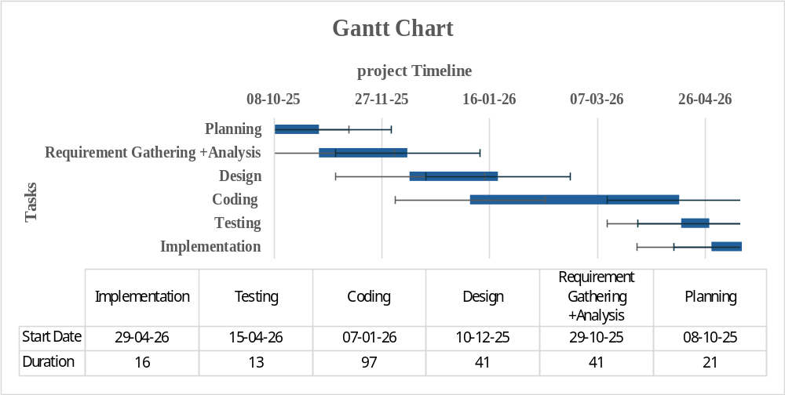
- Planning
- Requirement Gathering
- Analysis
- Designing
- Coding
- Testing
- Implementation

Summary
- The Digital Housing Society System is designed to automate the plot allotment process for housing
- societies. Manual balloting methods are time-consuming and often lack transparency.
- This system provides applicants with a fully online platform to register, submit their details, participate in the balloting process and instantly check their allotment results.
- By integrating secure authentication, applicant data management, automated draw generation, and real-time result viewing, the system ensures fairness, accuracy, and efficiency throughout the balloting cycle.
- Developed using Flutter and Firebase, the system delivers a responsive user interface, scalable architecture, and secure backend services.
- Firebase Authentication, Firestore Database, enable reliable data storage, controlled access, and automated randomization for plot allotment.
- The goal of the system is to offer housing societies a transparent, fast, and user-friendly digital balloting solution that enhances both administrative operations and applicant experience.

Chapter 2
Requirement Analysis

Analysis
This chapter presents a detailed analysis of the Digital Housing Society System. It identifies the different types of users interacting with the system and describes their characteristics. It also explains the techniques used to gather and define system requirements. The purpose of this chapter is to provide a clear understanding of user needs and system functionalities, which serve as the foundation for system design and development.

User Classes and Characteristics
Table 3 User Class and Characteristics for Proposed Project
User Class | Characteristics
Applicants (End Users) | Individuals applying for plots in the housing society. They have basic knowledge of mobile/web applications. They interact with the system to register, submit details, upload documents, make payments, and check results. They expect a simple, user-friendly, and fast interface.
Admin (System Administrator) | Responsible for managing the system operations. Has moderate technical knowledge. Perform tasks like verifying applicants, managing data, controlling balloting, and generating results. Require secure access and efficient control features.
Housing Society Management | Decision-makers who monitor system performance and results. They are less involved in daily operations but require accurate reports and transparency. They expect reliable and secure system output.

Requirement Identifying Technique
For the Digital Housing Society System, the Use Case Technique is used to identify and define system requirements. This technique is suitable because the system is an interactive application where users perform specific actions such as registration, login, balloting, and result checking.
Use Case Diagram
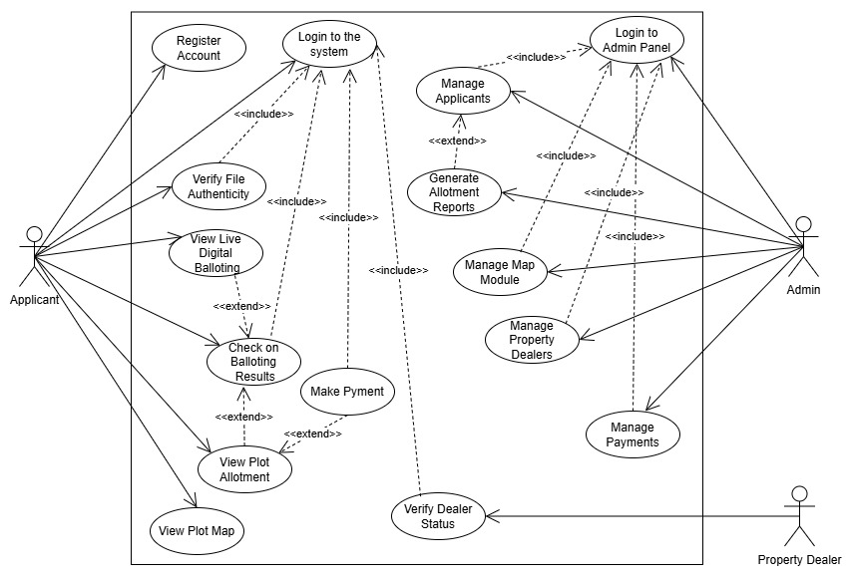
Figure 1 Use Case Diagram
Use Case Tables
- Use Case: Register User
Table 4 Use case: Register User
Field | Description
Actor | Applicant
Description | User registers by entering personal details
Pre-condition | User has valid CNIC and internet access
Post-Condition | User account is created successfully
Main Flow | - Open Registration Screen  - Enter Details  - System validates data  - Data stored in the database  - Confirmation message shown
Alternate Flow | Invalid CNIC → error message  Missing fields → ask to complete the form
- Use Case: Login User
Table 5 Use Case: Login User
Field | Description
Actor | Applicant/Admin
Description | User logs into the system using credentials
Pre-condition | User must be registered
Post-Condition | User is redirected to dashboard
Main Flow | - Enter email & password  - System verifies credentials  - Access granted
Alternate Flow | Wrong credentials → error message
- Use Case: Upload File
Table 6 Use Case: Upload File
Field | Description
Actor | Applicant
Description | User uploads required documents
Pre-condition | User is logged in
Post-Condition | File is stored with a unique serial number
Main Flow | - Select file  - Upload file  - System stores the file  - Serial number generated
Alternate Flow | Duplicate file → rejected
- Use Case: Make Payment
Table 7 Use Case: Make Payment
Field | Description
Actor | Applicant
Description | User submits payment details
Pre-condition | User is registered
Post-condition | Payment status updated
Main Flow | - Open payment screen  - Enter payment info  - Submit details  - Status updated
Alternate Flow | Payment failed → retry option
- Use Case: Verify Applicant
Table 8 Use Case: Verify Applicant
Field | Description
Actor | Admin
Description | Admin verifies applicant data
Pre-condition | Applicant has submitted data
Post-Condition | Applicant approved or rejected
Main Flow | - View applicant details  - Check documents  - Approve/Reject
Alternate Flow | Invalid data → reject

- Use Case: Start Balloting
Table 9 Use Case: Start Balloting
Field | Description
Actor | Admin
Description | Admin initiates balloting process
Pre-condition | Applicants are verified
Post-Condition | Balloting results generated
Main Flow | - Click start balloting  - System runs the algorithm  - Results generated
Alternate Flow | System error → retry

- Use Case: View Results
Table 10 Use Case: View Results
Field | Description
Actor | Applicant
Description | User checks balloting result
Pre-condition | Balloting completed
Post-Condition | Result displayed
Main Flow | - Enter CNIC  - System fetches the result  - Display result
Alternate Flow | No result → message shown

- Use Case: Manage Plots
Table 11 Use Case: Manage Plots
Field | Description
Actor | Admin
Description | Admin manages plot data
Pre-condition | Admin logged in
Post-Condition | Plot data updated
Main Flow | - Add/update plot  - Save data
Alternate Flow | Invalid data → error

- Use Case: Verify Dealer
Table 12 Use Case: Verify Dealer
Field | Description
Actor | Property Dealer / Admin
Description | This use case allows the system to verify the authenticity of a property dealer to prevent fraud
Pre-condition | Dealer must be registered and provide CNIC and required details
Post-Condition | Dealer status is updated as Verified or Unverified
Main Flow | - Dealer submits registration/details  - Admin views dealer information  - System checks CNIC format and data  - Admin verifies dealer  - Status updated in database
Alternate Flow | invalid or fake CNIC → dealer rejected  Missing information → request for resubmission

- Use Case: Generate Reports
Table 13 Use Case: Generate Reports
Field | Description
Actor | Admin
Description | Generate allotment report
Pre-condition | Results available
Post-Condition | Report generated
Main Flow | Request → Fetch data → Generate
Alternate Flow | Error
- Use Case: View Plot Map
Table 4-11 Use Case: View Plot Map
Field | Description
Actor | Applicant/Admin
Description | View plot visualization
Pre-condition | Data available
Post-Condition | Map displayed
Main Flow | Open map → View plots
Alternate Flow | Load error

2.3 Functional Requirements
The following are the core functional Requirements of our Digital Housing Society System, each grounded under its respective system feature. The system provides the following functional requirements:
- User Registration
- The applicant shall be able to register by entering personal details (CNIC, name, email, phone).
- The system shall validate input and display errors for invalid or missing data.
- User Authentication
- The system shall allow users to login using email and password.
- The system shall deny access and show error message for incorrect credentials.
- File Upload
- The applicant shall be able to upload required documents.
- The system shall reject invalid file formats and request re-upload.
- File Verification
- The system shall verify uploaded files using unique serial numbers.
- The system shall detect and reject duplicate or fake files.
- Payment Submission
- The applicant shall be able to submit payment details.
- The system shall show error if payment information is incomplete.
- Payment Verification
- The admin shall verify or reject submitted payments.
- The system shall update payment status accordingly.
- Applicant Verification
- The admin shall verify applicant information and documents.
- The system shall reject invalid or incomplete applications.
- Dealer Verification
- The admin shall verify property dealer details.
- The system shall reject dealers with invalid information.
- Start Balloting
- The admin shall initiate the balloting process.
- The system shall allow this only after verification is complete.
- Random Balloting
- The system shall randomly select applicants using an algorithm.
- The system shall ensure fairness and unbiased selection.
- Result Display
- The applicant shall be able to check results using CNIC.
- The system shall display selection status clearly.
- Report Generation
- The admin shall generate allotment reports.
- The system shall provide report data after balloting completion.
- Plot Management
- The admin shall add, update, and manage plot data.
- The system shall ensure each plot has a unique ID
- Plot Visualisation
- The system shall display plots using a static map.
- The system shall show plot allocation status visually.

Functional Requirements: User Registration
Table 14 Description of FR-1
Identifier | FR-1
Title | User Registration
Requirement | The applicant shall be able to register by entering valid personal details (CNIC, name, email, phone, password). If any required field is missing or CNIC format is invalid, the system shall display an error message and prevent submission.
Source | Applicant
Rationale | To allow users to create an account
Business Rule | CNIC must be unique and valid
Dependencies | None
Priority | High

Functional Requirement: User Authentication
Table 15 Description of FR-2
Identifier | FR-2
Title | User Authentication
Requirement | The system shall authenticate users using email and password. If incorrect credentials are entered, the system shall deny access and display an appropriate error message.
Source | System
Rationale | To ensure secure access
Business Rule | Only registered users can login
Dependencies | FR-1
Priority | High

Functional Requirement: File Upload
Table 16 Description of FR-3
Identifier | FR-3
Title | File Upload
Requirement | The applicant shall be able to upload required documents. If the file format is invalid or upload fails, the system shall display an error and request re-upload.
Source | Applicant
Rationale | To submit verification documents
Business Rule | Allowed formats only
Dependencies | FR-1
Priority | High

Functional Requirement: File Verification
Table 17 Description of FR-4
Identifier | FR-4
Title | File Verification
Requirement | The system shall verify uploaded files using unique serial numbers. If a duplicate or fake file is detected, the system shall reject it and notify the user.
Source | System
Rationale | To prevent fraud
Business Rule | Unique serial number required
Dependencies | FR-3
Priority | High

Functional Requirements: Payment Submission
Table 18 Description of FR-5
Identifier | FR-5
Title | Payment Submission
Requirement | The applicant shall be able to submit payment details. If payment information is incomplete or invalid, the system shall reject submission and prompt correction.
Source | Applicant
Rationale | To complete application
Business Rule | Payment required before balloting
Dependencies | FR-1
Priority | High

Functional Requirement: Payment Verification
Table 19 Description of FR-6
Identifier | FR-6
Title | Payment Verification
Requirement | The admin shall verify submitted payments. If payment proof is invalid, the system shall mark it as rejected and notify the applicant.
Source | Admin
Rationale | To ensure valid participation
Business Rule | Only verified payments allowed
Dependencies | FR-5
Priority | High

Functional Requirement: Applicant Verification
Table 20 Description of FR-7
Identifier | FR-7
Title | Applicant Verification
Requirement | The admin shall verify applicant data. If incorrect or incomplete data is found, the system shall reject the application and notify the user.
Source | Admin
Rationale | To ensure valid applicants
Business Rule | Verification required
Dependencies | FR-3
Priority | High

Functional Requirement: Dealer Verification
Table 21 Description of FR-8
Identifier | FR-8
Title | Dealer Verification
Requirement | The admin shall verify property dealer information using CNIC. If invalid data is detected, the system shall reject the dealer.
Source | Admin
Rationale | To prevent fraud dealers
Business Rule | Dealer must be verified
Dependencies | None
Priority | Medium

Functional Requirement: Start Balloting
Table 22 Description of FR-9
Identifier | FR-9
Title | Start Balloting
Requirement | The admin shall initiate balloting only after all applicants are verified. If conditions are not met, the system shall restrict the process.
Source | Admin
Rationale | To ensure fair process
Business Rule | Verification required
Dependencies | FR-6, FR-7
Priority | High

Functional Requirement: Random Balloting
Table 23 Description of FR-10
Identifier | FR-10
Title | Random Balloting
Requirement | The system shall randomly select applicants using a fair algorithm. If system failure occurs, the process shall be stopped and retried.
Source | System
Rationale | To ensure fairness
Business Rule | Must be unbiased
Dependencies | FR-9
Priority | High

Functional Requirement: Result Display
Table 24 Description of FR-11
Identifier | FR-11
Title | Result Display
Requirement | The applicant shall be able to view results using CNIC. If result is not found, the system shall display an appropriate message.
Source | Applicant
Rationale | To provide instant feedback
Business Rule | Results shown after completion
Dependencies | FR-10
Priority | High

Functional Requirement: Report Generation
Table 25 Description of FR-12
Identifier | FR-12
Title | Report Generation
Requirement | The admin shall generate reports after balloting. If data is unavailable, the system shall notify the admin.
Source | Admin
Rationale | For record keeping
Business Rule | Generated after results
Dependencies | FR-11
Priority | Medium

Functional Requirement: Plot Management
Table 26 Description of FR-13
Identifier | FR-13
Title | Plot Management
Requirement | The admin shall manage plot data. If invalid data is entered, the system shall reject and request correction.
Source | Admin
Rationale | To maintain records
Business Rule | Unique plot ID required
Dependencies | None
Priority | High

Functional Requirement: Plot Visualization
Table 27 Description of FR-14
Identifier | FR-14
Title | Plot Visualization
Requirement | The system shall display plots using a static map. If map fails to load, an error message shall be shown.
Source | System
Rationale | To provide visualization
Business Rule | Static map only
Dependencies | FR-13
Priority | Medium

2.4 Non-Functional Requirements
These quality requirements should be specific, quantitative and verifiable.

Performance Requirements
- The system should display balloting results in real-time without delay.
- The system should handle multiple users simultaneously during peak time (balloting).
- Response time for user actions (login, result check) should be within 3-5 seconds.
- The system should efficiently process randomized balloting algorithms.

Security Requirements
- User data (CNIC, personal info) must be encrypted and securely stored.
- The system must provide secure authentication (Firebase Authentication).
- Only authorized users (admin) can access admin panel (role-based access).

Usability Requirements
- The system interface should be simple, user-friendly, and easy to navigate.
- Font-size layout should be readable for all users.

Reliability Requirements
- The system should be available 24/7 for users.
- The system must ensure accurate and fair balloting results.
- In case of failure (server crash), system should:
- Recover data
- Resume operations without loss

Scalability Requirements
- The system should support increasing number of users (thousands of applicants).
- Database (Firebase Firestore) should scale automatically for:
- Data storage
- Real-time updates

Availability Requirements
- System should be accessible via:
- Mobile (Android/iOS)
- Web platform
- Requires stable internet connection to function properly.

Maintainability Requirements
- The system should be modular (MVVM architecture) for easy updates.
- Code should be:
- Well-structured
- Easy to debug and maintain
- Future features (e.g., NADRA verification) can be added easily.

2.5 External Interface Requirements
Here are the External Interface requirements of the system:

User Interfaces Requirements
- General UI Requirements
- The system follows basic usability standards such as readable font size, consistent layout, icons, proper color contrast, and clear labels.
- The system should be responsive and work on different screen sizes.
- Applicant Interface Requirements
- Registration and Login Screen
- Dashboard to view application and payment status
- Balloting Participation Screen
- Result Checking Screen (CNIC-based)
- File Upload and Verification Screen
- Admin Interface Requirements
- Admin Dashboard (view applicants, payments, reports)
- Applicant Verification Screen
- Balloting Control Panel
- Admin Login Screen
- Result Management Screen
- Navigation & Features
- Standard navigation options (Home, Login, Register, Dashboard, Logout) are available on all screens
- System displays error and success messages clearly (e.g. "Successful Registration", "Invalid Login Credentials").
- Notifications for balloting status and results

Software Interfaces
- Database System
- Firebase Firestore is used as a NoSQL Database to store the applicants' data, applications, plot details and results.
- Frontend Technologies
- Flutter Framework is used for front-end development to develop cross-platform UI.
- Dart Programming Language is used for Application Logic.
- Backend Services
- Firebase Authentication is used for secure login and registration.
- Firebase Storage is used for storing uploaded documents like CNIC images and files.
- Firebase Firestore for real-time database operations.
- Stripe API (Test Mode)
- Payment Gateway integration is used for handling payment simulation.

2.5.3 Hardware Interfaces
- System does not require any specialized hardware devices.
- It operates on general-purpose user devices such as mobile phones, laptops, and desktop computers.
- Supported devices
- Mobile devices (Android and iOS) used by applicants to register, apply, and check results
- Laptops or desktop computers used by admin to manage the system

2.5.4 Communication interfaces
- Network Requirements
- The system requires a stable internet connection for all operations.
- System communication is handled through secure HTTPS protocol.
- Data Communication
- SON format is used for data exchange between frontend and backend.
- Real-time data synchronization using Firebase
- Browser Support
- The System must be fully functional on modern browsers, including:
- Google Chrome
- Microsoft Edge (for web version)

2.6 Summary
- System Overview
This chapter described the overall structure and working of the Digital Housing Society System, including its purpose and key functionalities.
- Functional Requirements
The system’s core functionalities were defined, such as user registration, login, file upload, payment processing, verification, balloting, and result viewing.
- Use Case Modelling
Detailed use cases were presented to illustrate how different actors (Applicant, Admin, Property Dealer) interact with the system.
- User Interaction
The roles and responsibilities of different users were explained, showing how each actor performs specific tasks within the system.
- System Scope and Constraints
The scope of the system was defined along with its limitations, such as reliance on static maps and lack of real-time integration.
- Overall Importance
This chapter provided a clear foundation for system design and implementation by defining requirements and user interactions in a structured manner.
Chapter 3
Design and Architecture

System Design
Product Perspective
The Digital Housing Society System is a web and mobile-based application designed to automate the plot allotment process in housing societies. It operates as an internet-dependent system where users interact through a user-friendly interface developed in Flutter, while Firebase provides backend services such as authentication and data storage. The system maintains a centralized database for managing applicant information, payments, and balloting results. It functions as an independent system without direct integration with external platforms like NADRA, relying instead on internal validation and admin verification to ensure data accuracy.
System Overview
The Digital Housing Society System provides a complete digital solution for managing the housing society balloting process. It allows applicants to register, submit required details, upload documents, make payments, and participate in the balloting process. The system ensures transparency by using a random algorithm for fair selection and provides real-time result display. Admin users can manage applicants, verify data, control the balloting process, and generate reports. Overall, the system improves efficiency, reduces manual effort, and enhances user experience through automation and secure data handling.

Design Considerations
Assumptions:
- Correct Applicant information: Assumed that all the applicants provide correct and valid CNIC no, mobile numbers, and other personal info.
- Internet Connection: The system will have a stable internet connection for real-time results.
- Database server remains active: Assumes that the Database server will remain active, especially during balloting.
- Admin reviews data: Admin will verify the applicant's details before the balloting process.
- Randomization Process: Randomization algorithm works smoothly without any interruption.
- Housing Society data: The housing society data that the admin provides will be accurate and updated.
Dependencies:
- Internet Connection: A stable internet connection is required for accessing the website/mobile app properly.
- Authentication module: The system depends on an authentication mechanism to identify the applicants to prevent the system from unauthorized access.
- Random balloting algorithm: The system depends on a reliable randomization algorithm to generate transparent and fair results on the ballot screen.
- Database Storage: A database is required to store applicants, plots, payments, and balloting result details.
- Payment Method: The system depends on a payment method to process the registration fee and installments.
Limitations:
- No NADRA API Integration: Validation of CNIC cannot be done automatically, the system must rely on admin approvals, CNIC format checks, or CNIC image uploads.
- Stripe only works in Test mode: Real monetary transactions cannot be performed; payment features thus serve confirmation purposes only.
- Dependency on Stable Internet: Both admin and applicants were required to connect to the internet to perform operations.
- Performance Degradation: During balloting, large number of applicants may access the system simultaneously, it becomes difficult to handle them with improper scalability or optimization, it may slow down the system.

Risks:
- Fake CNIC IDs: Due to lack of NADRA CNIC verification, the system will face the issue of fake CNIC IDs.
- Data Security Vulnerability: Weak security measures may cause loss of applicants' credentials like (CNIC and personal details.)
- Stripe API Limitations: Stripe test mode may face limitations that cause payment issues/simulation.
- Server Crashes: Failure of the server may affect registration, payment simulation or balloting.
- Human Error in Verification: Any mistake by the admin during CNIC evaluation may lead to incorrect approval or rejection.

3.2 Design Models
The applicable models for the project using object-oriented development approach may include:
- Class Diagram
- Sequence Diagrams
- Class Relationship Diagram
- UML Component Diagram
- MVVM
- Client-server Architecture
- Multi-tier Architecture
- Class Diagram
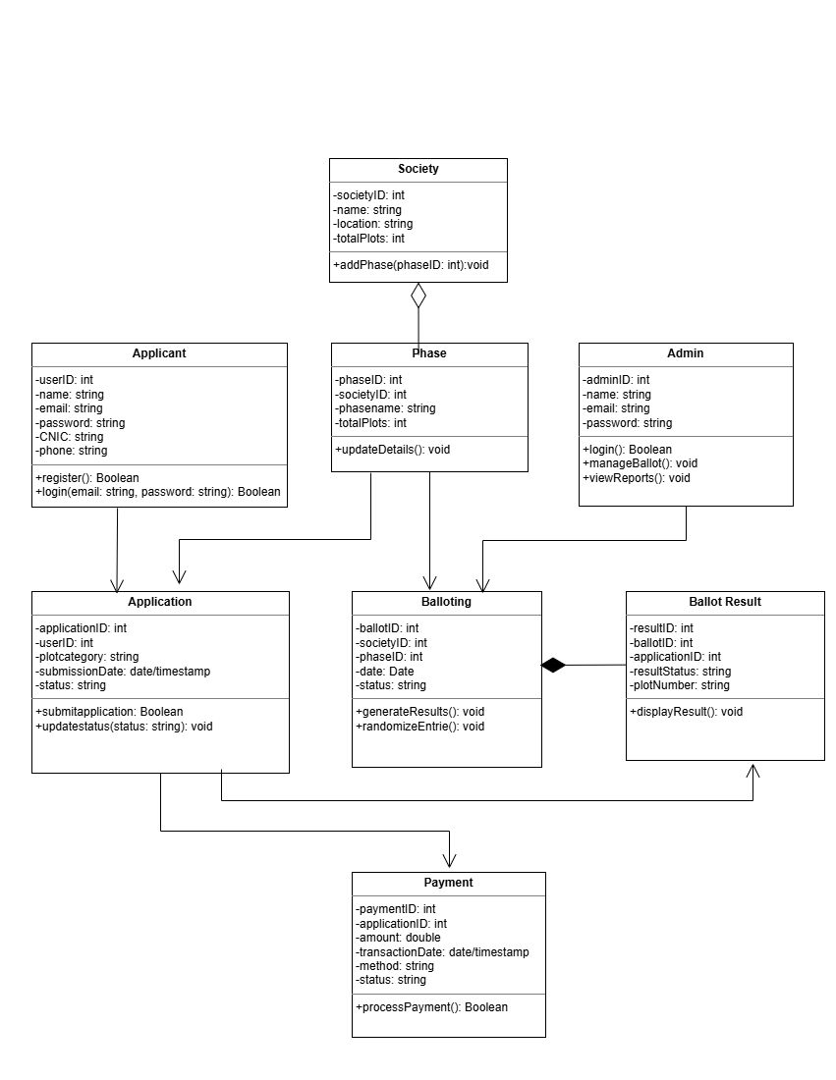
Figure 2 UML Class Diagram
- Sequence Diagram

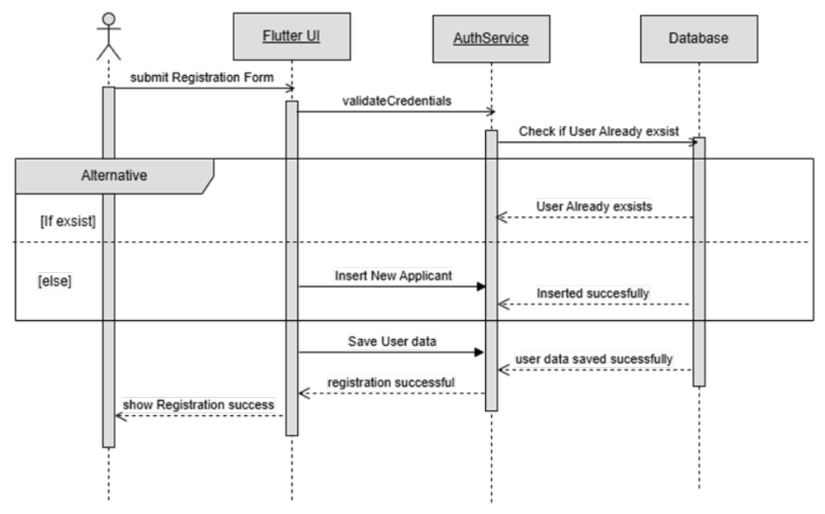

Figure 3 Registration Module Sequence

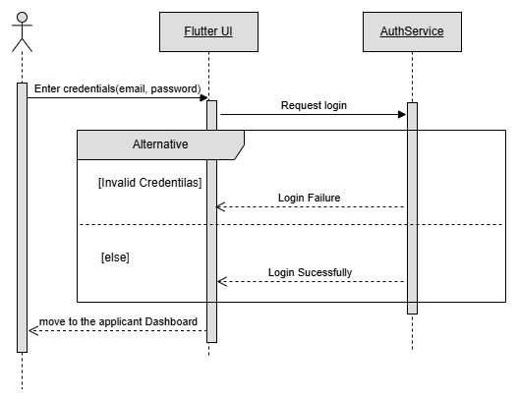

Figure 4 Login Module Sequence Diagram

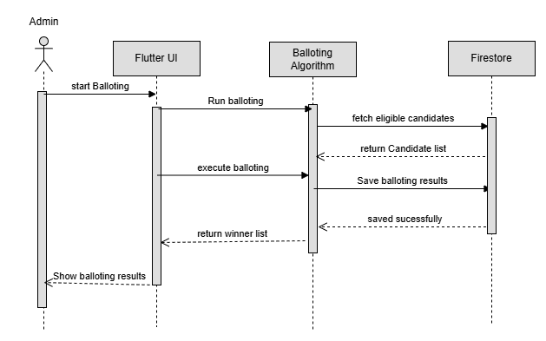
Figure 5 Digital Balloting Module Sequence Diagram
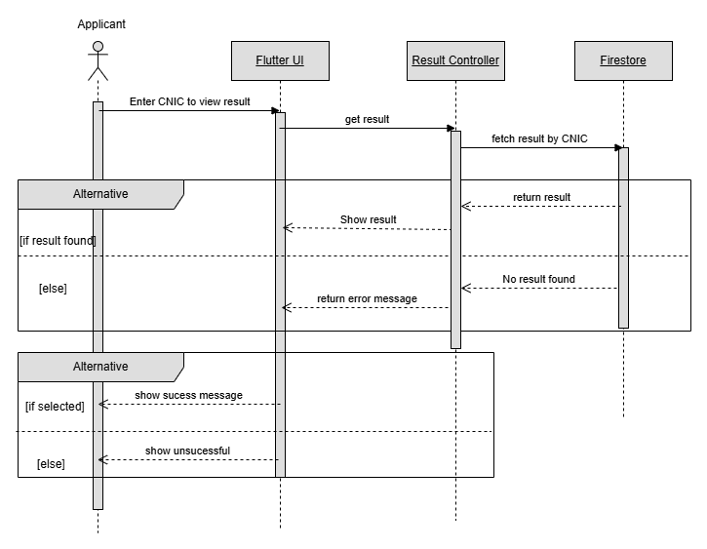

Figure 6 Result Display Module Sequence Diagram

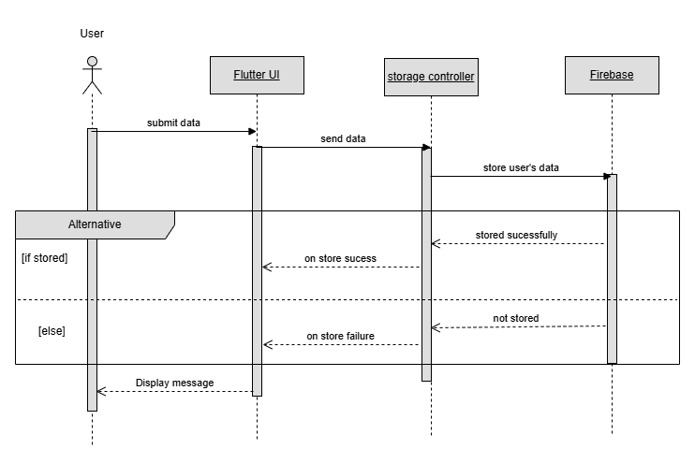Figure 7 Database Storage Sequence Diagram

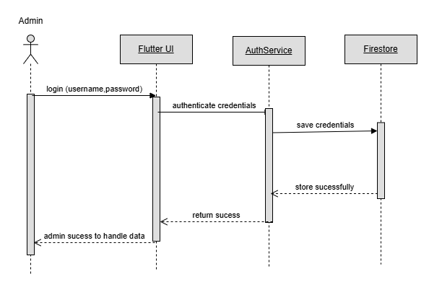
Figure 8 Admin Module Sequence Diagram

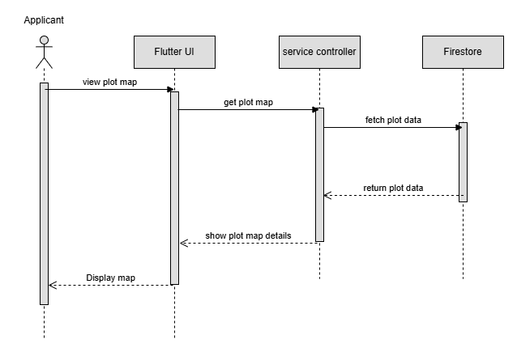

Figure 9 Plot Map Visualization Module Sequence Diagram

3.3 Architectural Design
- UML Class Relationship Diagram
Figure 10 Class Relationship Diagram
- UML Component Diagram
The UML Component diagram illustrates the high-level architecture of the digital housing society system, highlighting the interactions between various components.
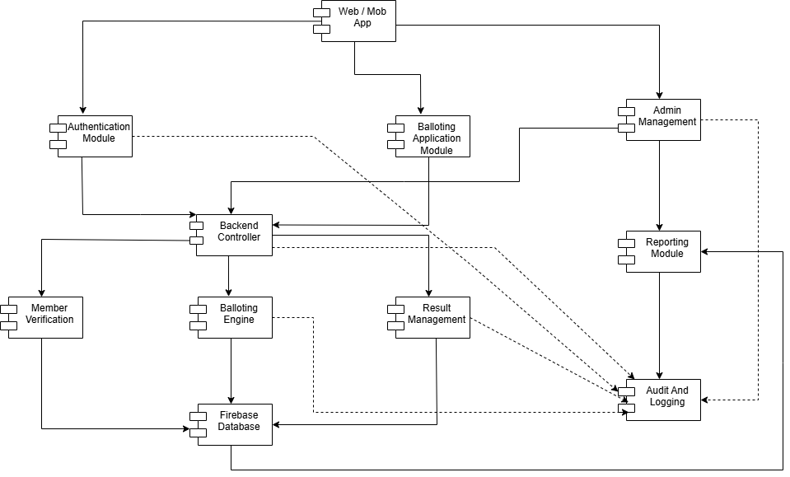
Figure 11 UML Component Diagram
Here's a detailed mapping of the digital housing society system using the multi-tiered architecture pattern:
- MVVM (Model View viewModel):
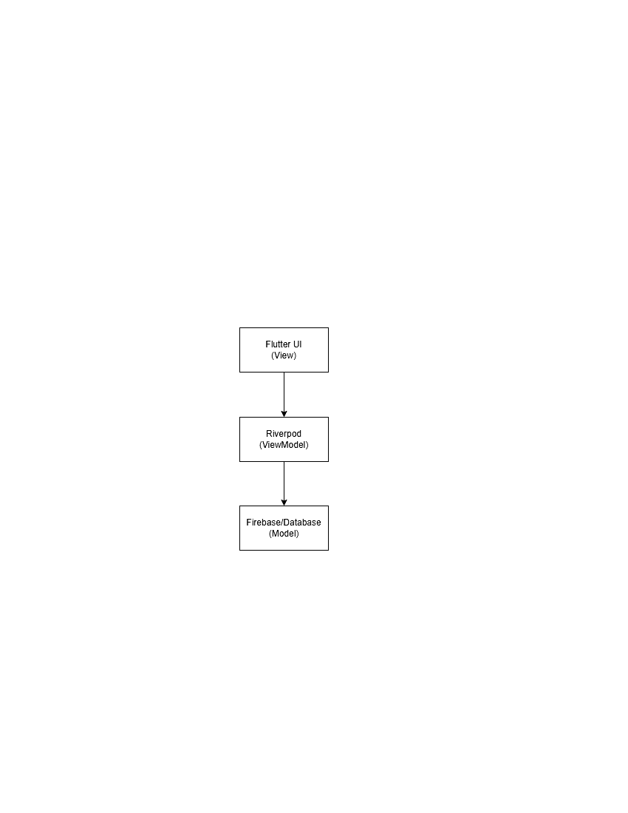
Figure 12 MVVM
- Client-Server Pattern
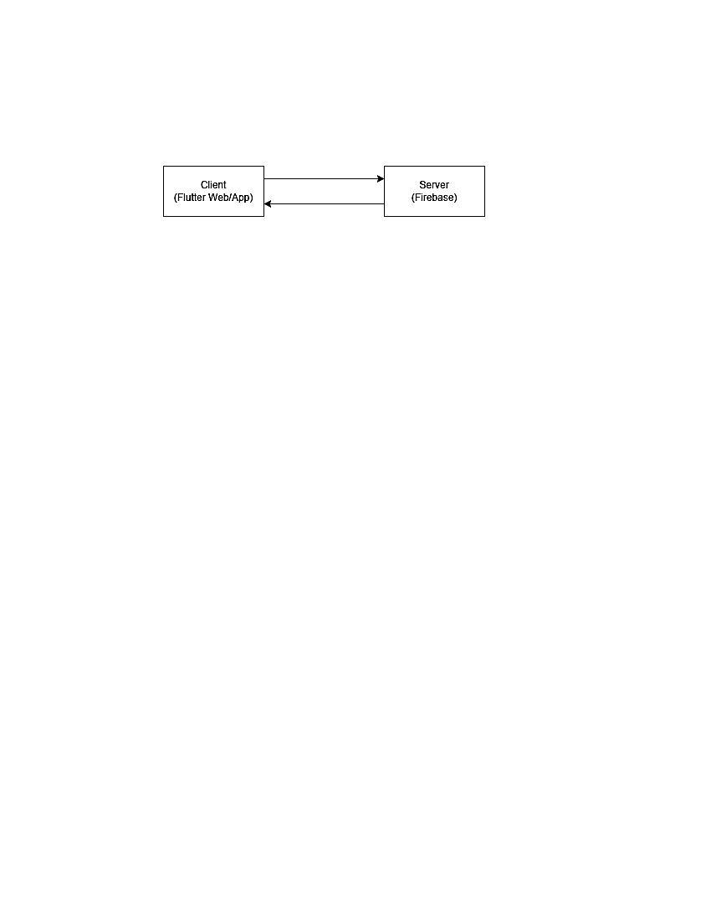
Figure 13 Client- Server Architecture
- Multi-Tier Architecture
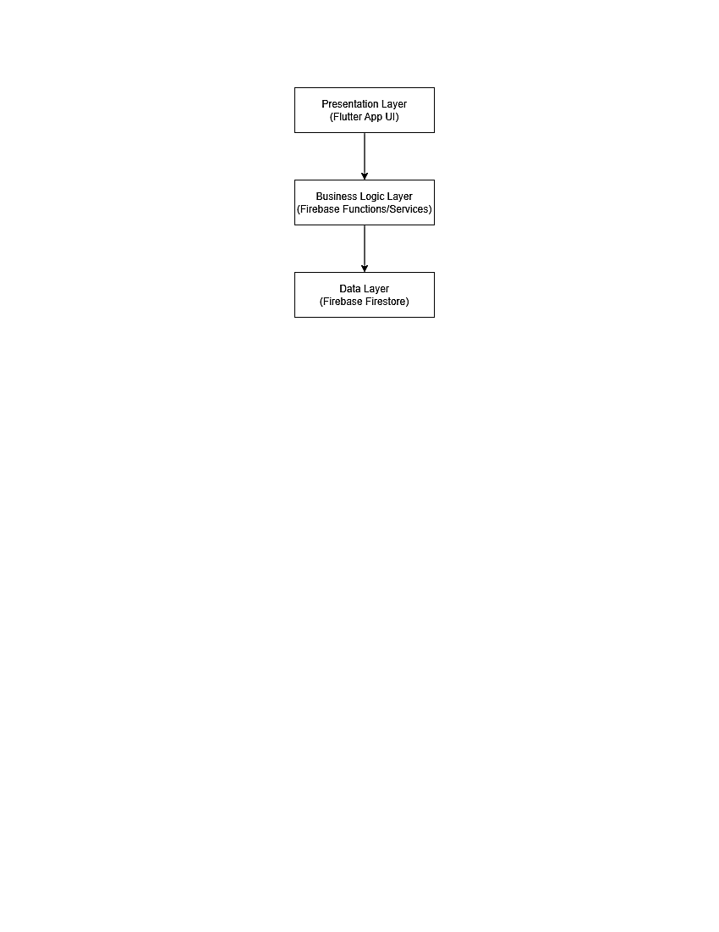
Figure 14 Multi-Tier Architecture

3.4 Data Design
Information Domain Overview:
The system uses major entities such as:
- Applicants: The System users who apply for the plots of the housing society. This system entity exists to store users’ registration details, CNIC verification, and balloting results.
- Admin: Responsible for handling the system by verifying users, managing plots, and generating reports.
- Plot: Used to store the basic plot information, such as plot size and allotment status.
- Balloting Result: Used to store the output of a random balloting algorithm. This entity ensures that applicants are informed of their selection status by displaying the result status.
- File verification: Used to detect fake and duplicate files. This entity exists to verify the authenticity of a file by assigning a unique serial number to it.
- Dealer verification: Used to prevent fraud in dealings. This entity is used to verify fake dealers.
- Map Representation Entity: Used to give a visual representation of the plots of the.
- Digital Allotment Reports: Used to store generate detailed reports after balloting.
Data Storage:
Our System uses Firebase Firestore, which is a NoSQL database. Data is organized in the form of collections and documents in the Firestore. Each collection is a group that contains the same type of records, such as the Applicant collection stores the data of all applicants. Each document is an individual record that contains fields like Name, CNIC, email, contact information, etc. Each document has a unique ID that identifies records and makes data retrieval easy.
Data Processing:
Data processing describes how data flows through the system.
Applicant’s Registration:
- Applicants fill out and submit their form.
- Flutter saves Frontend data in the Firebase Authentication and Firestore.
- System verifies the applicant’s CNIC and prevents duplicate applications
Applicant Login:
- Applicants send login requests.
- Firebase Authentication verifies credentials, and on successful login, the system shows the applicant dashboard.
File Verification:
- Applicant uploads the file.
- Unique serial numbers are assigned to the files in Firebase Firestore, and the system verifies the fake files.
Digital Balloting:
- Admin starts the balloting.
- Balloting module runs a random algorithm, and Firestore updates the data of successful applicants.
Result Checking:
- Applicants enter their CNIC and check their result.
- Flitter frontend fetches the result from Firestore and displays it to the applicants.
Digital Allotment Reports:
- Admin or applicant sends a report generation request.
- Data is retrieved from the Firestore, and reports are displayed on the front end.
Data Organization:
- Data is organized in a proper, structured format in the system so that the flow of information is clear and easy to understand.
- Each record is assigned with unique key to make searching fast and easy.
- Before entering data, validation rules are applied to prevent duplicate or fake data.
Data Dictionary
- Alphabetical List of System Entities or Major Data with Types and Descriptions:

Table 28 Data Dictionary

Entity | Description
Applicants | The System users who apply for the plots of the housing society. This system entity exists to store users’ registration details, CNIC verification, and balloting results.
Admin | Responsible for handling the system by verifying users, managing plots, and generating reports.
Balloting Result | Used to store the output of a random balloting algorithm. This entity ensures that applicants are informed of their selection status by displaying the result status.
DealerID | Used to prevent fraud in dealings. This entity is used to verify fake dealers.
Digital Report Allotment | Used to store the detailed reports generated after balloting.
Map Module | Used to give a visual representation of the plots of the society.
Plot | Used to store the basic plot information, such as plot size and allotment status.

Object-Oriented (OO) Approach: Objects, Attributes, Methods, & Method Parameters Objects & Attributes:
User
Attributes:
- UserID (String): Unique identifier for the applicant.
- Name (String): Applicant’s Full Name.
- Phone (String): Applicant’s contact Information.
- Email (String): Applicant’s email address.
- Password (String): Password for user authentication.
- CNIC (String): CNIC number for identity verification.
- UserType (Applicant, Admin): Whether the user is a regular applicant or admin.
File
Attributes:
- FileSerialNumber (String): Automated unique file serial number for fake file detection.
- SubmissionDate (Date): When the file was uploaded.
- isDuplicate (Boolean): checks whether the file is a duplicate or not.
Ballot
- Attributes:
- ballotDate (Date): Date of balloting.
- status (NotStarted, InProgress, Completed): Current live balloting status.
- totalApplicants (Integer): Total number of applicants included.
- selectedApplicants (List of Applicant): List of successful applicants.
Plot
Attributes:
- PlotID (String): Unique identifier for the plot.

- PlotSize (String): size category e.g. 3,5,10 Marla etc.
- PlotLocation (String): Location for map visualization.
- Status (Available, Booked): Plot availability state.
AllotmentReport
Attributes:
- reprtID (String): Unique identifier for dealer.
- Date: Date when allotmrnt was generated.
Dealer
Attributes:
- DealerID (String): Unique identifier for dealer.
- Name (String): Full name of dealer.
- Phone (String): Contact information of dealer.
- CNIC String): CNIC for identity verification.
- verificationStatus (verified, Unverified): dealer’s verification state.
Payment
Attributes:
- paymentId (String): Unique identifier for each payment.
- paymentDate (Date): Date of payment.
- paymentType (Online, Manual): Type of payment.
- status (Success, Failed, Pending): Transaction result.
Methods & Method parameters
User
- registerUser(name: String, phone: String, email: String, password: String, CNIC: String): Boolean.
- To register new account with the user.
- loginUser(email: String, password: String): Boolean

- verifyCNIC(CNIC: String): Boolean
- Verify user identity.
- changePassword (oldPassword:String , newPassword:String): Boolean
File
- uploadFile(fileData: File, applicantID: String): Boolean
- Attach file to the user account.
- Duplicate (fileSerialNumber: String): Boolean
- Verify duplicate file.
- generateFileSerial(): String
- System automatically generates unique file serial.
Ballot
- startBalloting(): void
- Initiate Balloting process.
- randomizeApplicants(applicantList: List): List
- List Shuffle applicants list for fair balloting.
- selectApplicants(applicantList: List, totalSlots: Integer): List
- Lists select applicants according to available lists.
- publishResults(selectedApplicants: List): void
- Show final results to the system.
Plot
- assignPlot(plotID: String, applicantID: String): Boolean
- Plot allotment to the applicants.
- updatePlotStatus(plotID: String, status: String): void
- Update Plot status: Available/Booked.
- getAvailablePlots(): List

- Return all the available plots.
Dealer
- verifyDealer(CNIC: String): Boolean
- Verify the dealer’s identity.
- updateStatus(dealerID: String, status: String): void
- Update verification status.
Payment
- makePayment(amount: Double, paymentType: String): Boolean
- Initiate Payment.
- verifyPayment(paymentID: String): Boolean
- Check whether the payment is successful or not.
- getPaymentStatus(paymentID: String): String
- Return payment status.

3.5 User Interface Design
The Digital Housing Society System provides a simple and user-friendly interface that allows applicants and admin users to interact with the system efficiently. Here's an overview of the functionality of the digital housing society system from the user's perspective:
User Roles
- Applicant: An applicant can register, login, apply for plots, upload files, make payments, participate in balloting, and check results.
- Admin: Admin can manage applicants, verify data and payments, control the balloting process, and view results.
Applicant Workflow
- Registration: The applicant registers by entering personal details such as name, CNIC, email, and contact information.
- Login: The applicant logs into the system using their credentials.
- Application Submission: The applicant submits application details and uploads required documents.
- Payment: The applicant makes payment through the system to become eligible for balloting.
- Balloting Participation: The applicant joins the balloting process after payment verification.
- Result Checking: The applicant checks the result using CNIC and views plot allotment status.
- Plot Map Visualization: Applicants can view a static map representation of available plots for a better understanding of plot locations.
Admin Workflow
- Login: Admin logs into the system using secure credentials.
- Applicant Verification: Admin verifies applicant details and uploaded documents.
- Payment Verification: Admin checks and verifies payment status.
- Balloting Control: Admin starts and manages the balloting process.
- Result Management: Admin views and manages final results and reports.
Feedback Information
- The system provides feedback to users through:
Notifications:
- Users receive notifications for balloting updates, application status, and payment verification.
System Messages:
- Success and error messages are displayed (e.g., “Registration Successful”, “Payment Failed”).
- Dashboard:
- Users can view their application status, payment status, and balloting results on the dashboard.
Expected Features
- User Registration and Login: User can create accounts and login securely.
- Application Submission: Applicants can submit their applications details.
- Payment Processing: Users can make payments for participation.
- Balloting System: System performs fair digital balloting using random selection.
- Real-Time Result Display: Results are displayed instantly to users.
- File Verification: System detects duplicate or fake files.
- Plot Map Visualization: Users can view plot locations visually.
- Admin Management System: Admin manages users, data, and balloting process.

Screen Objects and Actions
Use Case 1: Applicant Registration
Screen Objects:
- Input Fields (Name, CNIC, Email, Password)
- Register Button
Actions:
- Enter User Data: User enters required information in input fields
- Click Register Button: Clicking the Register button submits the data
- Validate input: System validates input ( format, required fields etc.)
- Display response: System displays success or error message
Use Case 2: Checking Balloting Result
Screen Objects:
- CNIC Input Field
- Check Result Button
- Result Display Area
Actions:
- Enter CNIC: User enters CNIC in the input field
- Click Check Result Button and Retrieve data: Clicking “Check Result” fetches data from the database
- Display Result: System displays result (Selected / Not Selected with plot details)
Use Case 3: Upload File
Screen Objects:
- File Upload Button
- File Selection Field
- Upload Status Message Area
Actions:
- Select File: User chooses a file from their device
- Click the Upload Button: Clicking upload submits the file to the system
- Validate File: System checks file format, size, and duplication
- Store File: System saves the file and generates a unique serial number
- Display Response: System shows success message or error (e.g., duplicate file)

3.6 Behavioral Model
- State Transition Diagram
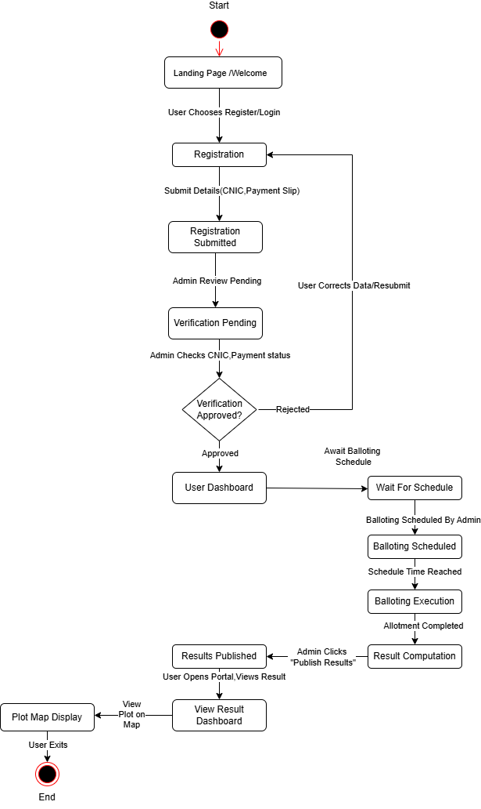
Figure 15 State Transition Diagram

3.7 Design Decisions
The following design decisions were made while developing the Digital Housing Society System:
- Frontend Framework
- Flutter: Framework is used for developing the user interface of the system. It supports cross-platform development (mobile and web) using a single codebase. It also provides a fast and responsive UI
- Backend Services
- Firebase (Backend as a Service): Firebase is selected as the backend because it provides real-time database, and built-in services such as secure authentication and cloud-based functions, which reduce development efforts.
- Database Design
- Firebase Firestore(NoSQL Database): Firestore is used as the database for storing applicant data, plot information, payment records, and balloting results. It is a NoSQL Database. Firestore is used because it provides real-time data synchronization, scalability, and flexible data structure, which is suitable for dynamic applications.
- Architecture Design Pattern
- MVVM: The system follows the MVVM (Model-View-View Model) architecture pattern. It is used to separate UI, business logic, and data handling. This makes the system more organized, maintainable, and easier to update.
- Balloting algorithm: A randomization-based algorithm is used for the balloting process . This ensures fairness and unbiased selection of applicants , which is a key requirement of the system.
- Authentication and security
- Firebase authentication: Firebase Authentication is used to manage user login and registration securely. It ensures that only authorized users can access the system.
- Payment Integration
- Stripe (Test Mode): A payment gateway, Stripe API, is integrated to simulate payment processing. It helps in managing user payments and verifying eligibility for balloting.
- Data Handling
- JSON-Based Data Exchange: JSON format is used for storing and transferring data between frontend and backend because it is lightweight, easy to use, and compatible with Firebase and Flutter.
- Cloud-Based System
- The system is designed as a cloud-based application. This allows users to access the system from anywhere, ensures data availability, and reduces the need for local infrastructure.

3.8 Summary
Here's the summary of the design ideas:
Design Ideas
- Object-Oriented Design / MVVM Pattern: Ensures clean architecture, modularity, reusability, and separation of UI and business logic using Flutter with Riverpod.
- Error Handling: Provides system stability by handling invalid inputs, failed requests issues with proper user feedback.
- Modularity: The system is divided into independent modules (authentication, plot management, balloting, payments), making development and maintenance easier.
- Scalability: Designed to efficiently handle a growing number of users, housing applications, and system records without performance issues.
- Usability: Offers a simple and user-friendly interface for applicants and administrators to easily interact with the system.
- Security: Ensures protection of user data and system processes through secure authentication and controlled access to features.
- Maintainability: Built with a structured and layered approach, making it easier to update and enhance features in the future.
Chapter 4
Implementation

Implementation
This chapter presents the implementation details of the Digital Housing Society System. It explains how the core components of the system are developed and how different modules function to achieve the overall objectives of the project. Instead of including actual source code, the main functionalities of key components are described using pseudocode to provide a clear understanding of the system logic and workflow.

Algorithms
This section describes the core algorithms used in the Digital Housing Society System. These algorithms define the logic behind major functionalities such as user authentication, file verification, and the balloting process. Each algorithm is presented in pseudocode form.
Table 29 Algorithm 1
Algorithm 1 User Authentication
Input: Email, Password
Output: Login Success / Failure
- START
- Input email, password
- IF email or password is empty THEN
- Display "Input Required"
- ELSE
- Fetch user data from database
- IF email AND password match THEN
- Display "Login Successful"
- ELSE
- Display "Invalid Credentials"
- END IF
- END
Table 30 Algorithm 2
Algorithm 2 File Verification
Input: Uploaded File
Output: Verified / Rejected
- START
- Input file
- Extract file serial number
- IF serial number exists in database, THEN
- Display "Duplicate File"
- Reject file
- ELSE
- Save file in database
- Mark file as verified
- END IF
- END

Algorithm 3 Random Balloting
Input: List of verified applicants
Output: Selected applicants
- START
- Input list of verified applicants
- Shuffle applicant list randomly
- Select required number of applicants
- Store selected applicants in result list
- Display results
- END
Table 31 Algorithm 4
Algorithm 4 Payment Verification
input: Payment details
Output: Verified / Rejected
- START
- Input payment details
- IF payment proof is valid THEN
- Mark payment as verified
- ELSE
- Mark payment as rejected
- END IF
- END
Table 32 Algorithm 5
Algorithm 5 Result Retrieval
Input: CNIC
Output: Selection Status
- START
- Input CNIC
- Search for CNIC in result database
- IF CNIC found THEN
- Display result (Selected / Not Selected)
- ELSE
- Display "Record Not Found"
- END IF
- END

External APIs/SDKs
This section describes the third-party APIs and SDKs used in the implementation of the Digital Housing Society System. These APIs help in enhancing system functionality, improving security, and enabling integration with external services.
Table 33 Description of External APIs/SDKs
Name of API and version | Description of API | Purpose of usage | List down the API endpoint/function/class in which it is used
Firebase Authentication (v9) | A secure authentication service provided by Google for user login and management | Used for user registration and login authentication | createUserWithEmailAndPassword(), signInWithEmailAndPassword ()
Firebase Firestore (v9) | NoSQL cloud database to store and sync data in real-time | Used for storing user data, applications, and results | addDoc(), getDocs(), updateDoc()
Stripe API (v3) | Online payment processing API | Used for handling user payments and verification | stripe.charges.create()
Cloudnary API (v1) | Cloud-based media management service | Used for uploading and storing user documents/files | upload ()

Code Repository
To effectively manage version control and collaboration for the group project, Git is used as the primary tool. All project-related files, including source code, documentation, and other relevant resources, are maintained in a centralised Git repository. This approach ensures proper tracking of changes, maintains a history of updates, and allows multiple team members to work simultaneously without conflicts.
The use of Git also helps in maintaining different versions of the project through branching and merging, ensuring that new features and bug fixes can be developed and tested independently before being integrated into the main project.
Git Repository Link
The repository for the group project can be accessed using the following link:

Metrics of the Git Repository
To ensure effective usage of the Git repository and maintain high-quality collaboration among team members, several key metrics are monitored throughout the project development lifecycle. These metrics help evaluate team performance, code quality, and project progress.
- Commits:
The number of commits is tracked to measure the frequency and consistency of contributions made by each team member. Regular commits indicate active development and proper version tracking.
- Branches:
The number of active and merged branches reflects how different features and modules are developed independently. Branching helps in isolating development work and ensures safe integration into the main codebase.
- Pull Requests:
Pull requests are monitored to analyse collaboration among team members. They show how changes are proposed, reviewed, and merged into the main branch, ensuring proper code validation before integration.
- Issues:
The number of open and closed issues represents the effectiveness of bug tracking, feature requests, and task management. Proper issue handling ensures timely resolution and organized workflow.
- Contributors:
This metric includes a list of all team members along with their contribution statistics such as number of commits, lines of code added, and lines removed. It helps in evaluating individual participation in the project.
- Code Reviews:
The number of code reviews conducted on pull requests ensures that the code meets quality standards and follows proper coding guidelines. It also promotes knowledge sharing among team members.

Summary
- Implementation Overview
This chapter explained how the system is implemented and how different modules work together to achieve the project goals.
- Core Algorithms
The main algorithms were presented in pseudocode form to describe the logic behind key functionalities such as authentication, verification, and balloting.
- External APIs / SDKs
Third-party tools and services used in the system were discussed, highlighting their role in enhancing functionality and performance.
- Code Repository Management
The use of Git for version control and collaboration was explained, ensuring proper tracking of project development.
- Repository Metrics
Important metrics such as commits, branches, pull requests, issues, and contributions were discussed to evaluate team performance and project progress.
- Overall Importance
This chapter demonstrated how the system is practically implemented, ensuring that it meets the defined objectives efficiently and follows standard development practices.

Chapter 5
Testing and Evaluation

Introduction
This chapter presents the testing strategy of Coder Digital Housing Society System. To ensure software verification and validation, a structured testing approach is followed covering Unit Testing, Functional Testing, Integration Testing, and Performance Testing. All test scripts conform to the following best practices:
- Keep Tests Independent: Each test must run independently of others to prevent cascading failures.
- Use Meaningful Assertions: Assertions clearly reflect the expected outcome and produce informative failure messages.
- Handle Test Data: Setup and teardown methods manage test data to keep the environment clean before and after each test.
- Avoid Hardcoding: Variables and configuration files are used instead of hardcoded values to keep tests maintainable.
- Make Tests Repeatable: Tests should be reliable and produce consistent results regardless of when or how many times they are executed.
Table 34 Testcase Template
Field | Description
Testcase ID | Unique identifier (UT1 for Unit Test 1, FT1 for Functional Test 1)
Requirement ID | ID of the requirement being tested
Title | Brief name of the feature or requirement under test
Description | Description of the features being tested
Objective | Why this test case is needed
Driver / Precondition | Setup required before test execution
Test Steps | Step-by-step instructions to execute the test
Input | Input values provided to the test
Expected Results | Expected outcome of the test
Actual Result | Actual outcome observed during execution
Remarks | Test status: Pass / Fail

5.1 Unit Testing (UT)
Unit testing focuses on testing individual parts of the system separately to ensure that each component performs its required function correctly. In this system, unit testing is applied to key features such as user registration, login, and result checking to verify that each function works as expected when provided with valid and invalid inputs.
Table 35 Unit Test Case UT1
Testcase ID | UT1
Requirement ID | R1
Title | User Registration (Valid Input)
Description | This test case verifies that a new user can successfully register into the system by providing valid personal and login information.
Objective | To ensure that the system correctly accepts valid input data and creates a new user account without errors.
Driver Precondition | The system is running properly, and no existing account is registered with the same CNIC or email address.
Test Steps | 1.Open Registration Screen.  2.Enter valid name, CNIC , email and password.  3.Click on “Register” button.  4.Observe system response.
Input | Valid user details (Name, CNIC, Email, Password)
Expected Results | The system should successfully register the user and store the data in the database, displaying a success message.
Actual Result | The user account was successfully created and stored in the database.
Test Status | Pass
Remarks | The registration module is functioning as expected without any errors.
Table 36 Unit Test Case UT2
Testcase ID | UT2
Requirement ID | R1
Title | User Login with Valid Credentials
Description | This test case verifies that a registered user can log in using correct credentials.
Objective | To ensure that the system authenticates valid users correctly.
Driver / Precondition | User must already be registered.
Test Steps | 1.Enter CNIC and password  2.Click Login
Input | Valid CNIC, Password
Expected Results | User is successfully logged into the system.
Actual Result | Login successful.
Test Status | Pass
Remarks | Authentication working properly.
Table 37 Unit Test Case UT3
Testcase ID | UT3
Requirement ID | R1
Title | User Login with Invalid Password
Description | This test case verifies system behavior when incorrect password is entered.
Objective | To ensure system rejects invalid login attempts.
Driver / Precondition | User account exists.
Test Steps | 1.Enter wrong password.  2.Click Login
Input | CNIC, Incorrect Password
Expected Results | System displays error messages and denies access.
Actual Result | Error displayed correctly.
Test Status | Pass
Remarks | Error handling works as expected.

Functional Testing (FT)
Functional testing is performed to check whether all features of the Digital Housing System are working correctly according to the user’s requirements. It focuses on how the system behaves from the user’s point of view and ensures that each function produces the expected output.
Table 38 Functional Test Case FT1
Testcase ID | FT1
Requirement ID | R2
Title | Application Submission Process
Description | This test case evaluates the ability of the system to accept and process application submissions.
Objective | To ensure that applicants can successfully submit their application data.
Driver / Precondition | User must be logged in.
Test Steps | 1.Fill application form  2.Click Submit
Input | Applicant details
Expected Results | Application is successfully submitted and stored.
Actual Result | Application submitted successfully.
Test Status | Pass
Remarks
  Feature working correctly.
Table 39 Functional Test Case FT2
Testcase ID | FT2
Requirement ID | R3
Title | Payment Processing and Status Update
Description | This test case evaluates the system’s ability to process user payments and update their status.
Objective | To ensure successful payment completion and status reflection.
Driver / Precondition | Users must be logged in and application submitted.
Test Steps | 1.Enter payment details  2.Click pays  3.Confirm transaction
Input | Payment information
Expected Results | Payment is processed and status updated.
Actual Result | Payment completed successfully.
Test Status | Pass
Remarks | Payment system functioning efficiently.
Table 40 Functional Test Case FT3
Testcase ID | FT3
Requirement ID | R4
Title | Balloting Process execution
Description | This test case verifies that the balloting process selects applicants randomly and fairly.
Objective | To ensure fairness and correctness of selection process.
Driver /Precondition | Applicant data must exist.
Test Steps | 1.Admin starts balloting  2.System generates results
Input | Applicant records
Expected Results | Random and fair selection is performed.
Actual Result | Balloting executed successfully.
Test Status | Pass
Remarks | Algorithms are working correctly.

5.3 Integration Testing (IT)
Integration testing verifies interaction between system components such as frontend, Firebase, and database. It ensures that different parts of the system work together as expected to produce the desired result. In the Digital Housing Society System, integration testing is applied to ensure smooth communication between the user interface and Firebase services. It verifies that data entered by users is correctly stored in the database, retrieved when required, and displayed accurately on the interface.
Table 41 Integration Test Case IT1
Testcase ID | IT1
Requirement ID | R1
Title | Registration and Database Integration
Description | This test case verifies interaction between frontend and Firebase database.
Objective | To ensure user data is stored correctly in database.
Driver /Precondition | Firebase must be connected.
Test Steps | 1.Submit registration  2.Check database
Input | User data
Expected Results | Data stored successfully in Firestore.
Actual Result | Data stored correctly.
Test Status | Pass
Remarks | Integration Successful.
Table 42 Integration Test Case IT2
Testcase ID | IT2
Requirement ID | R3
Title | Payment and Database Update Integration
Description | This test case verifies payment status updates in database.
Objective | To ensure correct synchronization of payment data.
Driver /Precondition | Payment must be completed.
Test Steps | 1.Perform payment  2.Check database
Input | Payment details
Expected Results | Payment status updated correctly.
Actual Result | Status updated successfully.
Test Status | Pass
Remarks | Data sync works properly.
Table 43 Integration Test Case IT3
Testcase ID | IT3
Requirement ID | R4
Title | Result Retrieval and Display Integration
Description | This test case verifies fetching and displaying results from database.
Objective | To ensure correct result display to users.
Driver /Precondition | Results must exist in database.
Test Steps | 1.Enter CNIC  2.Click Check Result
Input | CNIC
Expected Results | Correct result displayed to user.
Actual Result | Result displayed successfully
Test Status | Pass
Remarks | Integration working correctly

Performance Testing (PT)
Performance testing evaluates the responsiveness, stability, and scalability of the Digital Housing Society Balloting System under normal and heavy load conditions. The testing focuses on key operations such as user login, balloting process, and result retrieval.
Tool Used:
Firebase Performance Monitoring (or Manual Testing)
The system performance was analyzed using Firebase Performance Monitoring and manual testing techniques by simulating multiple users accessing the system simultaneously.
Table 44 Performance Testing Results
Tool/Method | Metric Measured | Result/Observation
Firebase Auth (Login) | Average response time (50 requests) | 95ms average, within acceptable range(<200ms)
Firestore (Fetch Applications) | Data retrieval response time | 120ms average, acceptable
Manual testing (Balloting Process) | Execution time | 1.5 seconds average, efficient for system
Manual Testing (Result Display) | Page load time | 130ms average, acceptable
Manual load simulation (20 users) | System stability | No crashes, response time increased to ~300ms
Observations
- All system operations responded within acceptable time limits under normal conditions.
- The balloting process was completed efficiently within a short time.
- Under concurrent load (20 users), the system remained stable with no crashes.
- Slight increase in response time was observed during peak usage.
- The system performance can be further improved with optimization and scalability enhancements.

Table 45 Performance Test Case PT1
Testcase ID | PT1
Requirement ID | R4
Title | Balloting Execution Time
Description | This test case measures the time taken to complete balloting
Objective | To ensure fair and quick allocation
Driver /Precondition | User registered
Test Steps | 1.Start Balloting  2.Process applicants
Input | Multiple applicants
Expected Results | Execution within 2 seconds
Actual Result | ~1.5 seconds
Test Status | Pass
Remarks | Performance acceptable
Table 46 Performance Test Case PT2
Testcase ID | PT2
Requirement ID | R2
Title | System Load Handling
Description | Test system with multiple users
Objective | To check system stability under load
Precondition | Multiple users accessing system
Test Steps | 1.Simulate 20 users  2.Perform login and result check
Input | Multiple requests
Expected Results | No crash, acceptable delay
Actual Result | Stable ~300ms delay
Test Status | Pass
Remarks | Performance satisfactory
Table 47 Performance Test Case PT3
Testcase ID | PT3
Requirement ID | R7
Title | Static Plot Map Loading Performance
Description | This test case checks the loading performance of the static plot map screen in the system
Objective | To ensure that the static plot map loads quickly and displays correctly without delay
Precondition | User is logged in and has access to the plot map screen
Test Steps | 1.Login into the system  2.Navigate to Plot Map screen  3.Observe loading time on the map  4.Verify map is displayed correctly
Input | User session active, map data from Firebase
Expected Results | Plot map should load within 1–2 seconds and display correctly without distortion
Actual Result | Plot map loaded successfully within expected time (1–2 seconds) and displayed correctly.
Test Status | Pass
Remarks | No performance issues observed during testing

5.5 Summary
This chapter presented the testing strategy of the Digital Housing Society System. Different levels of testing applied to the Digital Housing Society System including unit, functional, integration, and performance testing were conducted. These testing methods ensure that the system is reliable, correct, and efficient. The results show that the system performs as expected and meets the defined requirements. Proper testing improves system quality and helps with delivering a secure and error free application.
Chapter 6
System Conversion

Introduction
System conversion is the process of replacing an existing system with a new system while ensuring a smooth transition of data, operations, and users.
In the Digital Housing Society System, system conversion is required to shift from a manual or semi-digital housing management system to a fully automated digital platform. This includes transferring applicant records, plot details, and payment data into the new system.

6.1 Conversion Method
For this project, the Parallel Conversion method was adopted.
- This method allows both old(manual) and new(digital) systems to run simultaneously for a limited time.
- This ensures data accuracy and verification.
- Parallel conversion allows comparison between manual records and system-generated results, helping to identify and correct errors before full deployment.
- Although this method may require extra effort, it is suitable for this project as it ensures a safe, transparent, and low-risk transition from manual to digital operations.

6.2 Deployment
This section represents the steps required to make the software operational.
Steps followed:
- Application Build
- Flutter application is compiled into APK/Web version.
- Backend Process
- Firebase services (Authentication, Firestore Database, Storage) are configured.
- Database Setup
- Collections (Users, Applications, Plots, Payments) are created.
- Environment Configuration
- Firebase SDK integrated into system
- API keys and configuration files also added.
- Testing after Deployment
- Core functionalities such as registration, login, application submission, and balloting were tested.
- System performance and data synchronization were verified.

6.2.1 Data Conversion
The data conversion process involved:
- Data Extraction: Existing dummy or sample data (users, applications, plots) was collected from development storage or local files and prepared for migration into Firebase Firestore.
- Data Cleaning: Remove duplicate and test records and validate the structure and format of data(CNIC, email, and phone number consistency).
- Data Transformation: Converted the clean data into JSON format compatible with Firebase Firestore collections.
- Data Loading: Imported clean data into deployment Firebase Firestore using Firebase console or scripts.
- Backup and Restore: A backup and restore script was prepared to ensure data could be recovered in case of failure.

6.2.2 Training
Training is required to help users understand the system.
Use Case 1: User Registration and Application
- Open the application
- Click on “ Register Account”
- Enter personal details(Name, Email, CNIC, Password)
- Login using registered credentials
- Navigate to “Apply for plot”
- Select plot type and submit application
- System confirms successful submission
Use Case 2: Balloting and Result Checking
- Admin logs into system
- Navigate to “ Manage Applicants”
- Verify applicant records
- Initiates balloting process
- System randomly selects winners
- Generate allotment reports
Applicant Steps:
- Login to the system
- Navigate to “Check Balloting Results”
- View result status
- If selected, proceed to payment
- View plot allotment details

6.3 Post Deployment Testing
Post deployment testing included the following steps:
- Verify user registration functionality
- Validate login authentication
- Test application submission process
- Execute balloting algorithms and verify randomness
- Check payment processing workflow
- Validate database operations in Firestore

6.4 Challenges
Table 48 Challenges & Solutions

Challenges | Solution
Duplicate and incorrect records in manual data | Applied data cleaning and validation techniques
Errors in configuration and authentication setup | Correct API setup and testing
Maintaining transparency and randomness | Implemented Fisher-Yates Shuffle algorithm for unbiased results
Application performance issues on different devices | Tested on multiple Android devices and optimized performance
Users unfamiliar with digital systems | Designed a simple user interface and provided basic training

6.5 Summary
This chapter describes the system conversion and deployment process of Digital Housing Society System. The Parallel Conversion Method was used to ensure a safe transition from the old system to the new one. Deployment included application setup, database configuration, and testing.
Data conversion ensured accurate migration of records, while user training helped users understand the system. Post-deployment testing verified system functionality. Several challenges, such as data inconsistencies, deployment issues, and user adaptability issues, were encountered and successfully resolved through proper validation, testing, and user guidance.
Chapter 7
Conclusion

Introduction
This chapter presents the conclusion of the Digital Housing Society System project. It evaluates the extent to which the project objectives and goals have been successfully achieved and discusses the overall outcomes of the system. Additionally, this chapter highlights the limitations of the current system and suggests possible improvements and future enhancements that can be implemented to further improve the system’s performance, functionality, and user experience.

Evaluation
This section evaluates whether the objectives defined in Chapter 1 have been successfully achieved in the developed system.
Table 49 Objectives and their status
Objectives | Status
Provide secure user registration and login system. | Completed
Enable users to apply for housing schemes online. | Completed
Verify user documents and prevent duplicate applications. | Completed
implement transparent balloting system for plot allocation. | Completed
Provide real-time application status tracking | Completed
Allow admin to manage users, applications, and results | Completed
Ensure data storage and retrieval through database | Completed
Provide a user-friendly interface for all user types | Completed
Integrate file upload and verification system | Completed

Traceability Matrix
This matrix shows the relationship between system requirements, design components, implementation (code), and testing. It ensures that all requirements are properly implemented and tested in the system.
Table 50 Traceability Matrix
Requirement ID | Requirement Description | Design Specification | Code | Test ID
R1 | Applicants can register and join the system | Registration Module | Registration_screen.dart | UT1, IT1
R2 | Prevent fake/ duplicate registrations using CNIC verification | Authentication  Module | Login_screen.dart | UT2, UT3
R3 | Randomized balloting process for applicants | Balloting Screen | Balloting_screen.dart | FT3
R4 | Daily balloting results in real-time. | Result Display Module | Result_screen.dart | IT3
R5 | Stores applicants, plot and payments records. | Database storage  (Firestore) | Firebase_service.dart | IT,IT2
R6 | Admin manages users and balloting schedule | Admin panel Module | Admin_dashboard.dart | FT3
R7 | Displaying ststic map of plots | Plot Map Visual Module | Map_screen.dart | PT3

Conclusion
The Digital Housing Society System successfully fulfills the objectives defined at the initial stages of the project. The system provides a structured and efficient platform for managing housing applications, ensuring transparency and fairness in the balloting process.
It simplifies user interaction by allowing applicants to register, submit applications, make payments, and check results through a user-friendly interface. The integration of Firebase ensures reliable data storage and real-time updates, while proper testing ensures system stability and performance. Overall, the system meets its intended goals and provides an effective solution for digital housing management.

Table 51 Objectives and Functionality Provided
Objective | Functionality Provided
Online registration and application system | Users can register and submit applications online
Ensure fair balloting | Random selection system for applicants
Real-time result display | Users can check results instantly
Preventing Duplicate Applications | CNIC-based validation ensures uniqueness
Secure data handling | Firebase ensures data security
Admin management | Admin manages applicants and results

7.4 Future Work
- Mobile Application Development: Develop an Android/iOS app for better accessibility.
- Email/SMS Notification: Send alerts for registration, payments, and balloting results.
- Live Chat Support: Enable real-time communication between users and admin.
- Payment Gateway Integration: Allow secure online payments for fees and instalments.
- AI-Based Recommendations: Suggest plots based on user preferences.
- Analytics Dashboard: Display user activity, payments, and plot statistics.

References
Capital Development Authority. (n.d.). Balloting results and housing schemes. https://cda.nitbgov.pk
Defense Housing Authority. (n.d.). Housing schemes and balloting system. https://www.dha.org.pk
Lahore Development Authority. (n.d.). Balloting and application system. https://lda.gop.pk/
The News International. (2025). Housing plot applications and demand report. Zameen.com. (n.d.). Real estate portal in Pakistan. https://www.zameen.com

Appendix A
Use Case Description Template

Appendix A Use case description (Fully Dressed Format)
Table 52 UC-1
Use Case ID: | UC-1
Use Case Name: | Register User
Actors: | Applicant
Description: | Allow a new user to create an account by entering personal details.
Trigger: | User selects “Register” option
Preconditions: | User has valid CNIC and internet access
Postconditions: | User account is successfully created
Normal Flow: | - User opens registration screen  - User enters personal details  - System validates input data  - System stores data in database  - Confirmation message is displayed
Alternative Flows: | - 3a: Invalid CNIC → system shows error  - 3b: Missing fields → user prompted to complete form
Business Rules | - CNIC must be unique and valid format  - Password must meet security criteria
Assumptions: | User provides correct and authentic data

Table 53 UC-2
Use Case ID: | UC-2
Use Case Name: | Login User
Actors: | Applicant, Admin
Description: | Allows users to log into the system
Trigger: | User enters login credentials
Preconditions: | User must be registered
Postconditions: | User is redirected to dashboard
Normal Flow: | - User enters email & password  - System verifies credentials  - Access is granted
Alternative Flows: | 2a: Wrong credentials → error message
Business Rules | Only registered users can login
Assumptions: | Database is available and accessible
Table 54 UC-3
Use Case ID: | UC-3
Use Case Name: | Upload File
Actors: | Applicant
Description: | User uploads required documents
Trigger: | User selects upload option
Preconditions: | User is logged in
Postconditions: | File stored with unique ID
Normal Flow: | - Select file  - Upload file  - System stores file  - Serial number generated
Alternative Flows: | 3a: Duplicate file → rejected
Business Rules | Only file formats accepted
Assumptions: | File size within limits
Table 55 UC-4
Use Case ID: | UC-4
Use Case Name: | Make Payment
Actors: | Applicant
Description: | User submits payment details
Trigger: | User opens payment module
Preconditions: | User registered
Postconditions: | Payment status updated
Normal Flow: | - Open payment screen  - Enter payment details  - Submit  - Status updated
Alternative Flows: | 3a: Payment failed → retry
Business Rules | Payment must be valid
Assumptions: | Payment gateway is functional
Table 56 UC-5
Use Case ID: | UC-5
Use Case Name: | Verify Applicant
Actors: | Admin
Description: | Admin verifies applicant data
Trigger: | Admin selects applicant
Preconditions: | Data submitted
Postconditions: | Approved/Rejected
Normal Flow: | - View details  - Check documents  - Approve/Reject
Alternative Flows: | 2a: Invalid data → reject
Business Rules | Only admin can verify
Assumptions: | Documents are uploaded
Table 57 UC-6
Use Case ID: | UC-6
Use Case Name: | Start Balloting
Actors: | Admin
Description: | Initiates balloting process
Trigger: | Admin clicks start
Preconditions: | Applicants verified
Postconditions: | Results generated
Normal Flow: | - Click start  - System runs algorithm  - Results generated
Alternative Flows: | 2a: System error → retry
Business Rules | Only verified applicants included
Assumptions: | Algorithm runs correctly
Table 58 UC-7
Use Case ID: | UC-7
Use Case Name: | View Results
Actors: | Applicant
Description: | User views balloting result
Trigger: | Enter CNIC
Preconditions: | Balloting completed
Postconditions: | Result displayed
Normal Flow: | - Enter CNIC  - System fetches result  - Display result
Alternative Flows: | 2a: No record → message
Business Rules | CNIC must match database
Assumptions: | Results exist
Table 59 UC-8
Use Case ID: | UC-8
Use Case Name: | Manage Plots
Actors: | Admin
Description: | Manage plot data
Trigger: | Admin opens module
Preconditions: | Admin logged in
Postconditions: | Data updated
Normal Flow: | - Add/update plot  - Save
Alternative Flows: | 1a: Invalid data → error
Business Rules | Only admin allowed
Assumptions: | Database accessible
Table 60 UC-9
Use Case ID: | UC-9
Use Case Name: | Verify Dealer
Actors: | Property Dealer, Admin
Description: | Verify dealer authenticity
Trigger: | Dealer submits data
Preconditions: | Dealer registered
Postconditions: | Verified/Rejected
Normal Flow: | - Dealer submits details  - Admin reviews  - System validates CNIC  - Admin verifies  - Status updated
Alternative Flows: | - 3a: Fake CNIC → rejected  - 2a: Missing data → resubmit
Business Rules | Dealer must provide valid CNIC
Assumptions: | Admin performs verification

Table 61 UC-10
Use Case ID: | UC-10
Use Case Name: | Generate Reports
Actors: | Admin
Description: | Generate reports
Trigger: | Admin requests report
Preconditions: | Data available
Postconditions: | Report generated
Normal Flow: | - Request report  - Fetch data  - Generate report
Alternative Flows: | 2a: Error → retry
Business Rules | Only admin access
Assumptions: | Data exists

Table 62 UC-11
Use Case ID: | UC-11
Use Case Name: | View Plot Map
Actors: | Applicant, Admin
Description: | View plot visualization
Trigger: | Open map
Preconditions: | Data available
Postconditions: | Map displayed
Normal Flow: | - Open map  - View plots
Alternative Flows: | 1a: Load error
Business Rules | Authorized access only
Assumptions: | Internet connection available

Appendix-B
Coding Standards

General Coding Standards & Guidelines
This appendix outlines the general coding standards and best practices followed during the development of the Digital Housing Society System to ensure code readability, maintainability, and scalability.

1. Naming Conventions
Consistent naming conventions are followed throughout the project:
- camelCase → e.g., userName, applicationStatus (used for variables and functions)
- PascalCase → e.g., UserModel, PaymentService (used for class names)
- snake_case → may be used where required for external data formats (optional)
- Naming is meaningful and clearly describes the purpose of variables and functions
- Example: userId, paymentStatus, selectedApplicant

2. Immutability and Properties
- const and final keywords are used for variables that should not change after initialization
- Read-only data is handled through controlled access to ensure data integrity

3. Function and Method Standards
- Function names clearly represent their purpose, such as submitApplication() or processPayment()
- Functions are kept short, modular, and reusable
- Single Responsibility Principle (SRP) is followed, where each function performs one specific task

4. Comments and Documentation
- Meaningful comments are added to explain complex logic
- Unnecessary comments are avoided

Example style:
// Function to process user payment
void processPayment()
// payment logic here
}

5. Code Structure and Formatting
The following coding practices are maintained:
- Proper indentation is used to improve readability
- Files and folders follow a consistent naming convention
- Each screen, service, or model is placed in a separate file
Examples:
login_screen.dart , user_model.dart , payment_service.dart

6. Project Organization
The project follows a modular structure:
- Models → for defining data structures (user, application, result)
- Services → for Firebase operations (authentication, database handling)
- Screens → for user interface
- Widgets → for reusable UI components
Different layers such as UI, business logic, and data handling are clearly separated.

7. Scope and Access Control
- Variables and functions are defined within the minimum required scope
- Private variables are defined using underscore _ convention in Dart
- Controlled access ensures secure and proper data handling

8. Code Quality Principles
High cohesion and low coupling are maintained across modules
DRY (Don’t Repeat Yourself) principle is followed:
- Code duplication is avoided
- Common logic is reused through functions and widgets

9. Exception Handling and Logging
- Critical operations are handled using try-catch blocks
- Errors are properly handled to prevent application crashes
- Basic logging (e.g., debug prints) is used during development for debugging

10. Extendibility and Maintenance
- Code is written in a way that allows easy addition of new features
- Classes and components are designed to be reusable and extendable without modifying existing code

Appendix C
Prototype

Appendix-C: Application Prototype

Prototype Overview
The application prototype represents the initial design and user interface flow of the Digital Housing Society System. It demonstrates how users interact with the system before full backend integration.

Screenshots of Key Interfaces

Applicant Registration Page
- Description: Applicant enters credentials to access the system.
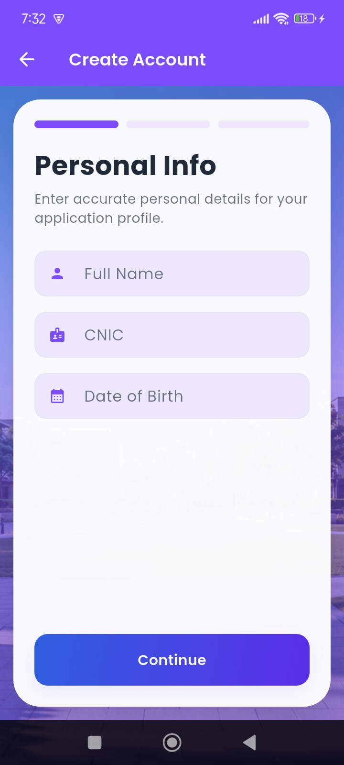
Figure 16 Applicant's Registration 1
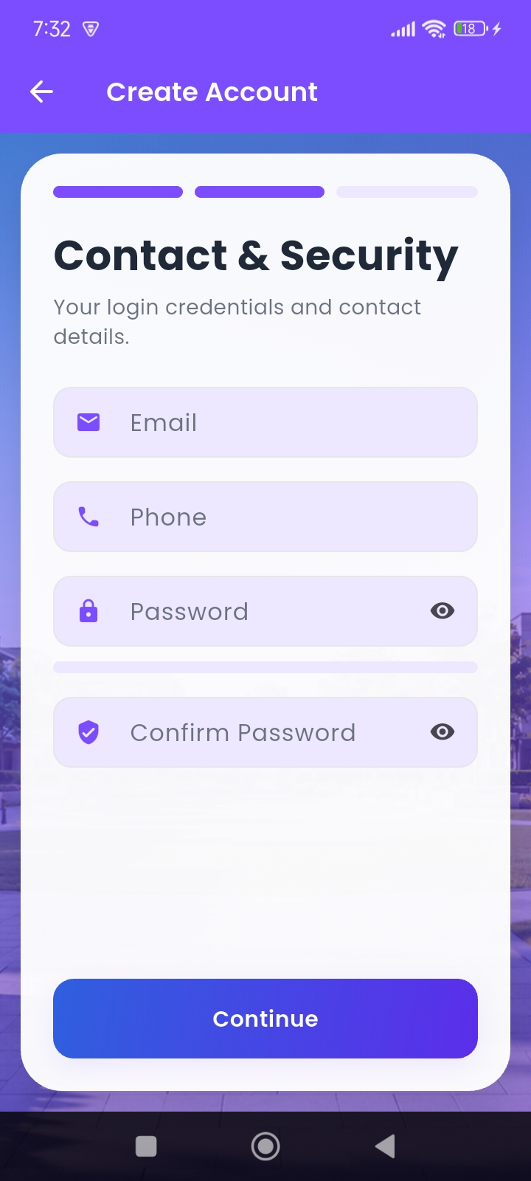
Figure 17 Applicant’s Registration 2
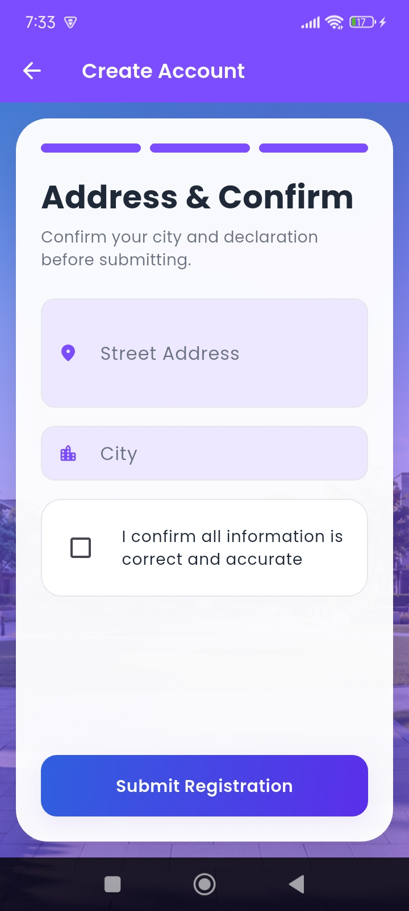
Figure 18 Applicant’s Registration 3

Applicant Login Page
- Description: After registering successfully, applicant logged into the system.
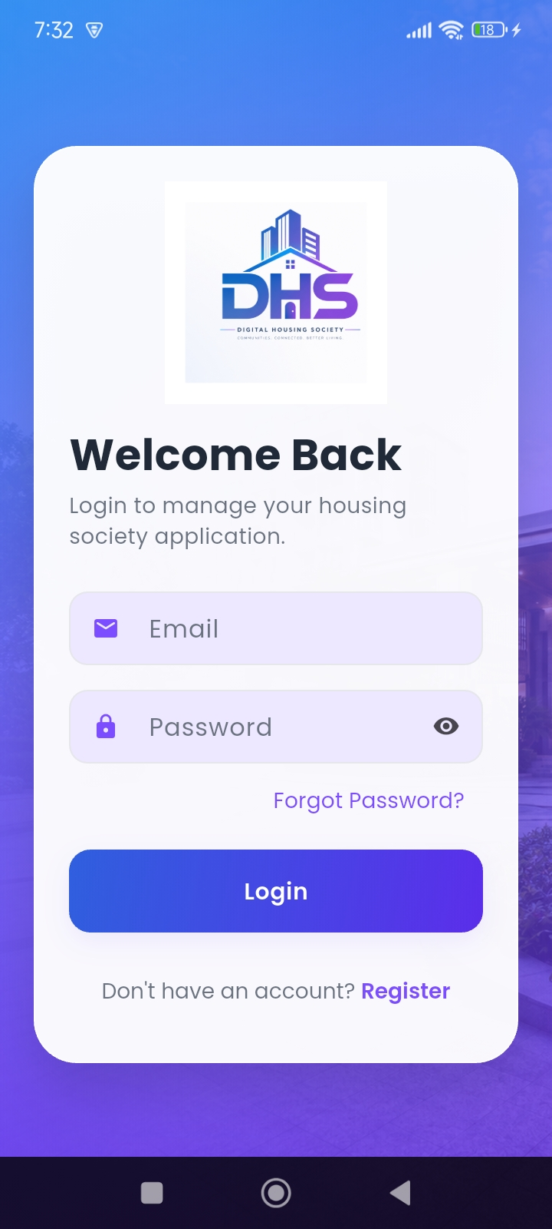
Figure 19 Applicant’s Login page

Live Balloting Session
- Description: Applicants participate in live balloting to achieve plots.
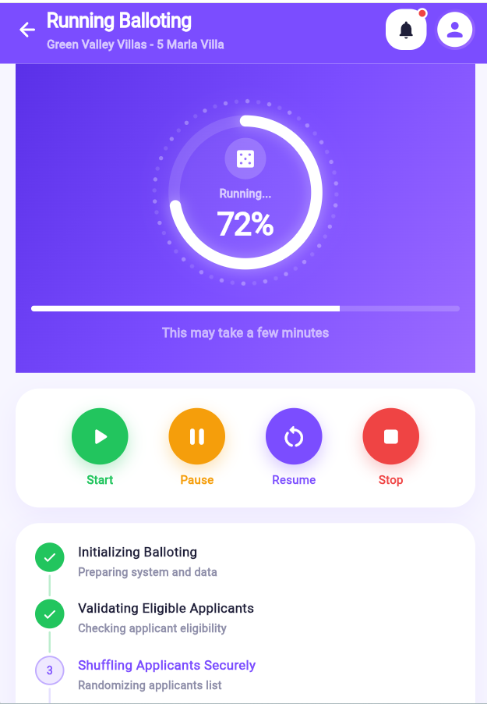
Figure 20 Live Balloting Session

Live Results
- Description: Admin manages the live results and applicants verify their result by their CNIC.
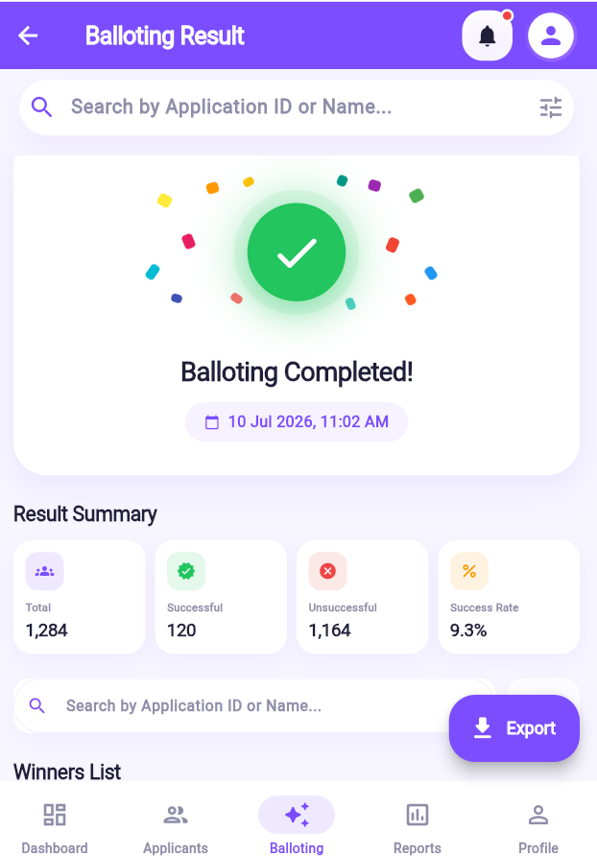
Figure 21 Live Results

Navigation Flow
Here’s the typical flow of the application:
Login/Register→Dashboard→(View Plots/Apply/Payments/Results)→Logout
Admin Login→Admin Panel→Manage System→Reports

Responsive Design
The application is fully responsive and optimized for:
- Desktop
- Tablet
- Mobile Devices

